How-To Guide

Developing and Implementing National Gender-Based Violence Multisector Service Delivery Protocols: Lessons from the Pacific

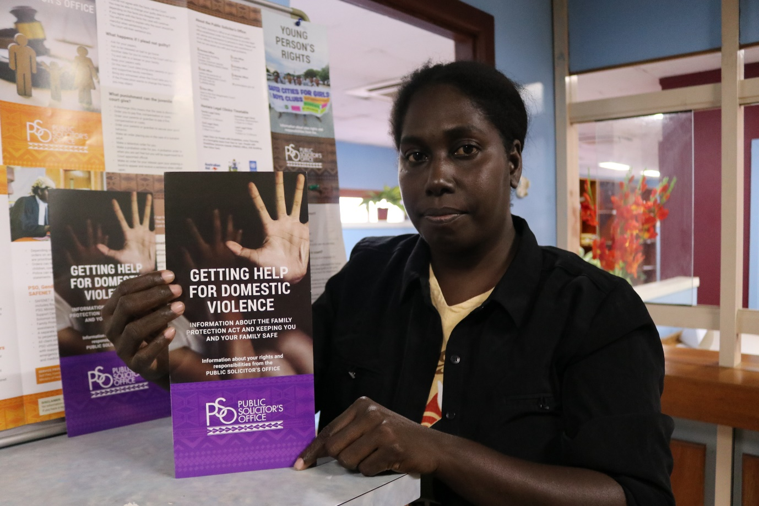
Cover photo: Ms Kathleen Kohata, Principal Legal Officer, Family Protection Unit, Public Solicitor’s Office (PSO). The PSO is a key member of Solomon Island’s national multisector gender-based violence service delivery system known as SAFENET. Photo credit: UN Women / Shazia Usman

Table of Contents
Developing and Implementing National Gender-Based Violence Multisector Service Delivery Protocols: Lessons from the Pacific 1
Introduction 2
Unpacking the problem 3
Advancing holistic solutions 5
Guiding principles and minimum standards 6
Referral pathways 8
Key roles and responsibilities 9
Confidentiality, informed consent and mandatory reporting 10
The development and implementation process 11
Developing and implementing a Service Delivery Protocol 11
Lessons learned from the Pacific 13
Recommendations 16
National governments 17
Civil society organisations and women’s movements 17
Technical partners 17
Donors 17
Acknowledgements 17

Introduction

This How-To Guide aims to support learning for Pacific Island governments, civil society and development partners.
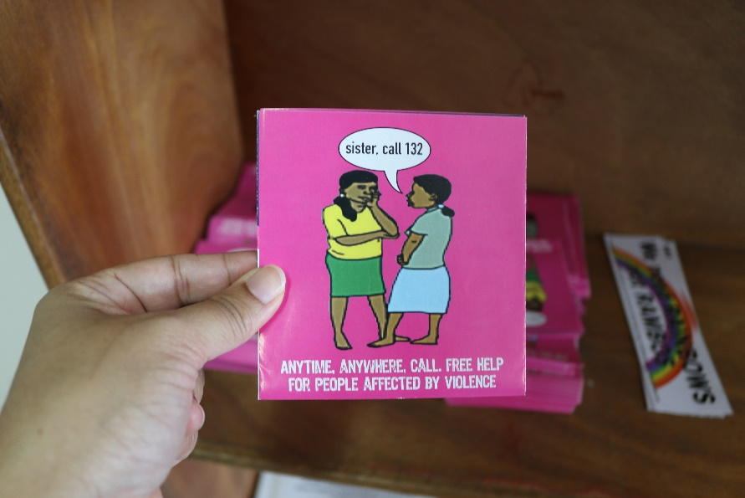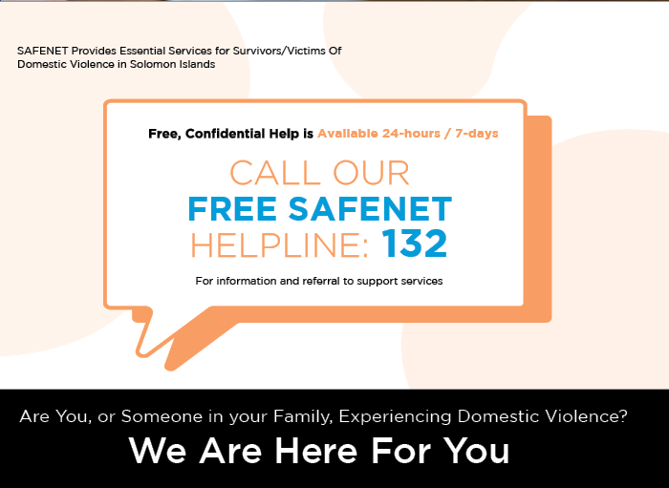

Addressing gender-based violence (GBV) requires a comprehensive approach that aims to both transform the underlying conditions that drive violence, such as harmful social norms, and ensure survivors of GBV have access to quality, multisector essential services. The application of a holistic, transformative approach focusing both on primary prevention (stopping violence before it starts), alongside secondary prevention (response services) which seeks to prevent the reoccurrence of violence, is key to a whole-of-government,
whole-of-society approach.
The provision, coordination and governance of essential, multisector health, police, justice and social services can significantly mitigate the consequences that violence has on the well-being, health and safety of women and girls’ lives, assist in the recovery and empowerment of women, and stop violence from reoccurring. One key component of developing coordinated, multisector care, at national and local levels, is to develop standard procedures that guide how key service providers work together to respond to cases of GBV and support survivors in their help-seeking journey. These standard procedures – known in the Pacific region as ‘Service Delivery Protocols’ or ‘Interagency Guidelines’ – are designed to ensure that services of all sectors are coordinated and governed to respond in a comprehensive way, are women-centred and, where necessary, child-centred, and are accountable to survivors and to each other.
Drawing on the diverse experiences across five Pacific Island countries - Fiji, Kiribati, Samoa, Solomon Islands and Tonga - this How-To Guide provides relevant background information and guidance on the step-by-step process of developing national multisector service delivery protocols and localised referral pathways.
Intended as practical, Pacific-specific guidelines, aligned with international and regional best practice, this How-To Guide aims to support learning for Pacific Island governments, civil society, and development partners on how to strengthen essential service delivery and coordination for survivors of GBV. 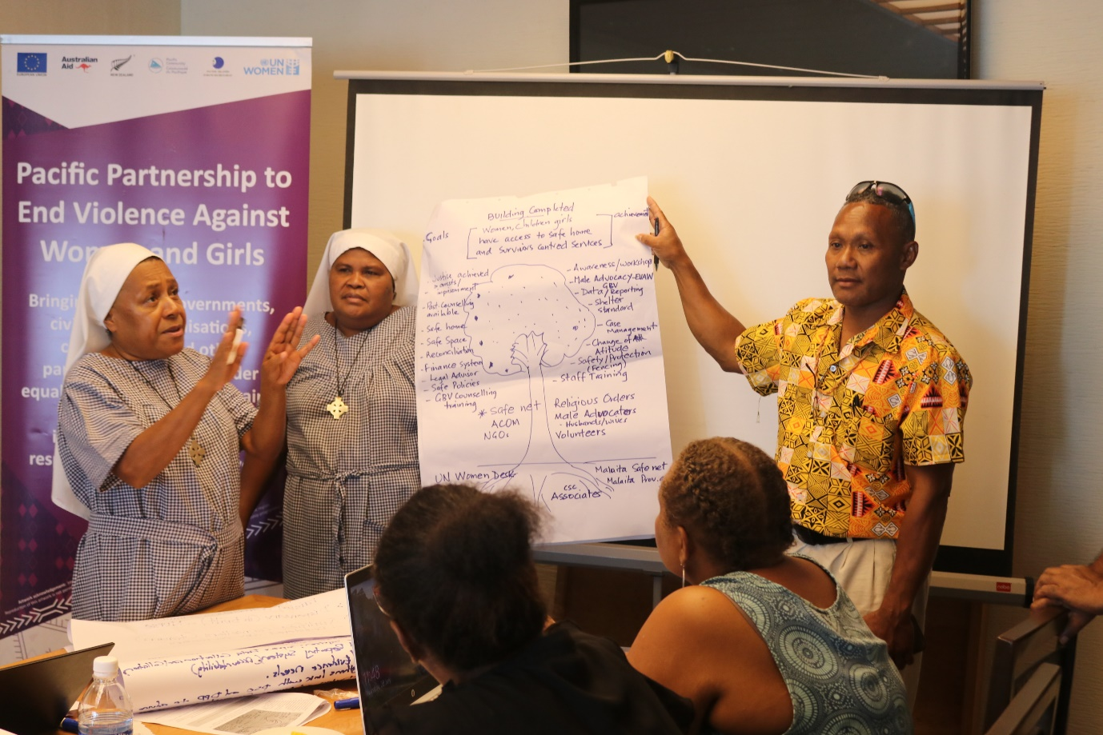

Unpacking the problem

Gender-based violence, or violence against women and girls (VAWG), is widespread, systemic and culturally entrenched. Violence against women consists of “any act of gender-based violence that results in, or is likely to result in, physical, sexual or psychological harm or suffering to women, including threats of such acts, coercion or arbitrary deprivations of liberty, whether occurring in public or in private life.” The Pacific has some of the highest rates of VAWG in the world, with almost two out of three women who have been subject to physical or sexual violence in their lifetime. This is double the global average (one out of three women) and most cases are perpetrated by an intimate partner (e.g., husband, partner). For example, studies show that 68% of ever-partnered women in Kiribati, and 64% of women in Fiji and Solomon Islands, report experiencing physical or sexual violence from an intimate partner in their lifetime.
The evidence shows that GBV is a serious issue in the Pacific and standard operating procedures, across agencies and sectors, is critical to a successful response. Currently, reports to police, health and social services remains low due to stigma, fear, shame, high levels of community tolerance of violence, inadequate response from police and legal services, and lack of access to services in some rural areas and smaller communities, with limited options or support to escape violence.⁴ A well-coordinated response across agencies responding to individual cases will improve practice and encourage more women and girls to come forward.
To ensure a quality response to cases of GBV, Service Delivery Protocols (SDPs) provide a framework for service delivery that is aligned with best-practice principles, is survivor centred, human rights-based, culturally appropriate, and empowers women throughout the healing and recovery process.
The development of an SDP is an integral part of a whole-of-government approach to ending GBV and aligns with international human rights treaties such as the Convention on the Elimination of All Forms of Discrimination Against Women, and the Convention on the Rights of the Child. These international treaties reflect a commitment to a quality of life for women and children that is free from violence. These human rights standards are translated into national law and policy, and in the development of SDPs across the Pacific. For example, in the context of the Solomon Islands, the national multisector service delivery system, known as SAFENET, is situated within the Solomon Islands National Gender Equality and Women’s Development Policy; the National Policy on Eliminating Violence against Women and Girls; the Family Protection Act; and the Child Welfare Act; and aligns with sectoral policies of health and justice.⁵

The Pacific has some of the highest rates of VAWG in the world.

Almost two out of three women have been subject to physical or sexual violence in their lifetime. This is double the global average. 68% of ever-partnered women in Kiribati report experiencing physical or sexual violence from an intimate partner in their lifetime. 64% of ever-partnered women in Fiji and Solomon Islands report experiencing physical or sexual violence from an intimate partner in their lifetime.

Advancing holistic solutions

What is a National Service Delivery Protocol for responding to cases of gender-based violence?

National Service Delivery Protocols for responding to cases of GBV (referred to as Service Delivery Protocols or SDPs hereafter) are part of a comprehensive essential service response approach globally and in the Pacific. SDPs help to ensure quality service provision that is timely and appropriate for survivors, and focused on taking action at the earliest signs of violence and intervening to prevent further violence. They provide guidance for frontline workers on core principles to guide care and treatment, steps for response, and safe and ethical practices in referrals, and outline key roles and responsibilities of health services, social services (i.e. crisis centres and shelters) and police and the justice sector service providers. SDPs also outline governance and coordination mechanisms which guide protocols and overall coordination.
A coordinated response improves practice and helps to meet the holistic needs of survivors through clearly defined roles and responsibilities and referral pathways. It also helps to mitigate risk and minimise the consequences on survivors. Coordinated care improves the response to individual cases and, in turn, builds trust, thus encouraging more women and girls to disclose and report in the future and help to break the cycle of violence.
Service coordination is at the heart of an SDP and occurs:
- at a national level between government and civil society partners engaged in GBV service delivery,
- at a local level between social services, health services, and police and legal services, to address violence and meet the needs of survivors,
- internally, between different levels of government at the national level, and
- between stakeholders that operate at both national and local levels.
An SDP provides a roadmap for how government branches, health and justice sectors, as well as specialised women’s services and community service organisations, can work together to respond in a coordinated response to GBV, and commits these services and organisations to a common set of principles and guidelines.

Guiding principles and minimum standards

The SDPs developed in the Pacific are aligned with best-practice principles and guidelines for coordination of essential services, in line with the United Nation’s Joint Global Programme on Essential Services for Women and Girls Subject to Violence ‘Essential Services Package’ and the Inter-Agency Minimum Standards for Gender-Based Violence in Emergencies Programming developed by UNFPA. The Pacific approach to developing coordinated multisector services, drawing upon both emergency and development frameworks, is to ensure seamless service delivery across the humanitarian-development continuum. The Pacific SDPs are primarily intended to be applied to the most prevalent forms of GBV, such as intimate partner violence and non-partner sexual violence, however, they may also be used in the response to other forms of GBV.
SDPs take a rights-based and culturally appropriate approach, emphasise safety, and seek to advance gender equality and women’s empowerment, and this is reflected across the core set of guiding principles and minimum standards. These guiding principles work to ensure a sensitive, compassionate and inclusive response for all survivors of violence, including women and children with disabilities, LGBTQI+ women, and women from other historically marginalised groups. Service provider signatories to the SDPs must also adhere to the minimum standards, such as prioritising confidentiality and safety, and doing no harm. The principles and minimum standards are articulated below and full definitions can be found in the United Nation’s Essential Services Package.
Each country can also adapt these principles and minimum standards to be useful and effective in their context, as well as develop and include additional principles or standards.
Through applying these minimum standards and guiding principles, SDPs offer a framework for a collective commitment to a safe and ethical response to GBV and seek to prevent the (re)victimisation of survivors that may occur through the conduct of service providers and/or through having to relay events to multiple people. These core commitments reflect the ‘survivor-centred approach’ that is at the centre of SDPs.

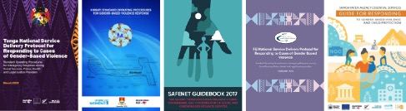

PRINCIPLES | DEFINITION
A rights-based approach | The responsibility to respect, protect, and fulfill the human rights of survivors.
Advancing gender equality and women’s empowerment | Recognise and address gender inequality as a root cause of GBV. Promote women’s agency and decision-making.
Culturally and age appropriate and sensitive | Respond appropriately to the individual circumstances and life experiences of survivors, and take into account multiple forms of discrimination.
Victim/survivor-centred approach | Place the rights, needs and desires of survivors at the centre of focus of service delivery.
Safety is paramount | Prioritise the safety and security of survivors and avoid causing further harm.
Perpetrator accountability | Hold perpetrators accountable whilst ensuring fairness in justice response and avoiding placing the burden of seeking justice on survivors.
MINIMUM STANDARDS | DEFINITION
Availability | Services must be available in sufficient quantity and quality to meet the needs of all survivors of violence.
Accessibility | Services are physically, economically, and linguistically accessible.
Adaptability | Recognise the differing impacts of violence on different survivors and communities and respond to their diverse needs.
Appropriateness | Services are delivered in ways that respect the survivor’s dignity, guarantees their confidentiality, and is sensitive to their needs and perspectives.
Prioritise safety | Prioritise mitigating immediate and ongoing risks to survivor’s safety through risk assessment and management.
Informed consent and confidentiality | Services are delivered in a way that protects survivors’ privacy, guarantees confidentiality and discloses information only with their informed consent, as far as the law allows.
Data collection and information management | Consistent and accurate collection and safe storage of data to support the continuous improvement of services.
Effective communication | Information is communicated in ways that survivors easily understand and empowers them to make informed decisions.
Linking with other sectors and agencies through referral and coordination | Ensure the smooth and safe navigation of survivors through different essential services within different sectors.

Adapted from The United Nations Joint Global Programme on Essential Services for Women and Girls Subject to Violence, (2015). Essential Services Package, Module One: Overview and Introduction & UNFPA (2019). The Inter-Agency Minimum Standards for Gender-Based Violence in Emergencies Programming.

Referral pathways

Acknowledging that survivors of violence require many varied services to respond to their particular cases and aid healing and recovery, referral pathways are established within the SDP to guide the journey to recovery. A list of essential services that includes, but is not limited to, case management, counselling, healthcare, police and justice, shelters and child protection, is provided in the SDP. This ensures service providers are aware of other services (and their internal processes) within the referral network and that referrals between providers are made (and received) which meet the individual needs of the survivor.
Referral pathways respond to, and manage, risk and develop context-specific channels and networks to aid survivors’ recovery. Typically, these referral pathways include:
- establishing safety and security – police
and shelter
- provision of healthcare and treatment – physical and socio-psycho support
- accountability for the perpetrator –
justice responses and child protection
- additional and ongoing support – case management, advocacy and holistic needs, including housing and counselling
- additional referral points to emergencies.
The referral pathways designate roles and responsibilities in a first and immediate response
to the disclosure of violence:
Step 1 | Obtain informed  consent for referral
Step 2 | Prepare the survivor with information about the services
Step 3 | Make accompaniment  plans for referral based  on survivor’s wishes
Step 4 | Document the  referral choice
Step 5 | Conduct any  follow-up required
Following the immediate response, referral pathways establish the follow up and ongoing support for the survivor, including if they wish to pursue legal action. Follow-up responses also acknowledge and manage potential ongoing risk to the survivor and/or their child(ren).

Key roles and responsibilities

An integral component of the SDP is outlining the key roles and responsibilities of both government and civil society frontline response services – health, police and justice, social services (crisis centres, shelters, counselling), as well as the role of the National Women’s Machineries in overall coordination and governance of SDPs.

Roles and responsibilities
National Women’s Machineries | Health services | Police and justice system | Social services
- Law and policy  - Governance and coordination of the SDP  - Coordination between relevant government departments  - Overseeing monitoring and evaluation of the SDP  - Shared data management  - National research  - Prevention, advocacy and skills training  - Funding and resource mobilisation | - Screening and identification of survivors  - Medical care and treatment  - Sexual assault examination and care  - Documentation  - Mental health assessment, care and treatment  - Sexual reproduction health services | - Provide security for survivors  - Pursue a ‘no drop policy’ for GBV matters that is communicated transparently to survivors  - Update survivors on the progress of any investigation | - Provision of immediate support:  - Helplines  - Crisis support and information  - Counselling and case management  - Crisis accommodation and shelter  - Legal rights and referral to legal aid  - Safety planning  - Provision of ongoing support:  - Psycho-social support  - Financial services  - Children’s services  - Prevention initiatives:  - Community awareness raising  - Training and education
Shared roles and responsibilities
- If first contact, make arrangements for medical examination, treatment and care
- Report/share information and refer
- Explore opportunities for collaboration and joint case management
- Use accessible language
- Be sensitive, compassionate and inclusive of all survivors, and refer to services that meet their individual needs
- Ensure that survivors are not (re)traumatised and minimise the number of times and persons a survivor must recount their story to
- Keep perpetrator in view, take action to hold perpetrator to account, and manage risk

Confidentiality, informed consent and mandatory reporting

Different countries have different laws when it comes to reporting GBV, especially in relation to different approaches based on age and development. It is important to understand that an adult survivor has the right to choose whether they report an incident of violence to the police. Mandatory reporting by service providers is only used under two circumstances: when an adult survivor is in imminent risk of harm or danger by another person or to themselves, and when dealing with cases of violence against children. Mandatory reporting of adult GBV cases is NOT best practice, as it can inadvertently create additional safety risks. It is critical, when managing cases, that the complexity of the survivor’s situation is clearly recognised and understood. The SDP, therefore, must be adapted to the legislative context of the country, while remaining committed to the core guiding principles of survivor-centred care, including confidentiality and informed consent.
Confidentiality promotes safety, trust and empowerment for survivors. It means that information related to the survivor and their experience of violence will not be shared without the expressed consent of the survivor. In order to give their consent, the survivor must be properly informed about the services on offer, what they provide and any limitations, what information will be shared, with whom it will be shared, how it will be shared, and the risks and benefits of sharing the information. Once the survivor has this information, they can give their informed consent for the information to be shared within, and across, services in order to provide a response that meets the needs of the individual survivor.
Informed consent is the voluntary agreement of a person with the legal capacity to give consent, meaning they must be of legal age, sound mind, conscious and unaffected by any substances, so they can understand the information presented to them. There are exceptions to confidentiality, such as when there is an unacceptable and immediate risk to the survivor and/or their child(ren), or if the survivor is unable to give consent. In these situations, safety is given priority and information is shared to keep survivors and/or their child(ren) safe. Under usual circumstances, however, information cannot be shared without the consent of the survivor.
In the case of mandatory reporting – for example, with child survivors or if a survivor is at risk of harm or harm of another person – the limitations of confidentiality must be transparently communicated to the survivor prior to them disclosing the details of the incident. In this way, the survivor is able to make an informed decision to disclose and is empowered with the choice and time of the disclosure.
To uphold confidentiality, the following practices must be observed:
- Conduct interviews and assessments in a secure and private setting.
- Gain the informed consent of the survivor prior to sharing information.
- Only share information as requested and agreed by the survivor, excepting those situations when the survivor cannot give their consent or when there is an unacceptable level of risk.
- Limit the number of people with information about the survivor and/or their case.
- The people supporting the survivor and/or involved with the case must not divulge information to their friends, family or colleagues who are not involved.
- Information about the survivor in public documents must be
de-identified.
- Data relating to the survivor and/or case can only be collected and stored with the consent of the survivor. Any data collected must be stored securely within the organisation and only accessible to agreed persons.

The development and implementation process

The process of establishing a national SDP must be tailored to the country’s specific context and needs. However, based on the experiences of Pacific countries who currently have SDPs in place, when best-practice principles are applied, the development and implementation of an SDP follow a similar process with key common steps.
Before an SDP can be developed and put into effect, a country must first establish laws and policies which support the implementation and coordination of services to address and respond to GBV. Once this foundation is in place, it is important to engage and consult widely with a diverse array of service providers and stakeholders in different regions throughout the country. These consultations must acknowledge that services have different roles and will have different levels of knowledge and understanding of GBV as they enter the consultation process. The consultation therefore offers an opportunity to construct a shared understanding of GBV and develop a shared commitment to responding to violence based on best-practice guiding principles and the national context.

Developing and implementing a Service Delivery Protocol

- Legal and policy frameworks:
- Created by national governments
- Supports the development and coordination of essential services
- Designation of roles and responsibilities to key government ministries and agencies
- Establish a designated position/role to oversee the SDP development and implementation process
- Establish adequate funding streams
- Wide consultations:
  - Led by relevant government ministries
  - Engage with wide variety of stakeholders
  - Communicate benefits of an SDP and construct shared understandings of GBV
  - Identify scope of SDP
  - Identify core group of people to direct and be involved throughout the process
- Drafting and validation:
  - Collaboration between stakeholders
  - Identify impediments and challenges to coordination and implementation in different regions of the country
  - Identify gaps in service provision
  - Develop risk mitigation strategies
  - Draft and review SDP documents in collaboration with stakeholders
  - Stakeholders endorse SDP in validation process
- Roll out:
  - Governed by relevant government ministries and partner agencies
  - Development of internal policy and procedures in line with the SDP within each service
  - Development of shared referral forms and risk assessments
  - Development of localised referral pathways
  - Training and skills development for all stakeholders
  - Develop safe and ethical GBV information management procedures
- Accountability
  - Monitoring and evaluation led by relevant government ministry
  - Oversight and assessment of stakeholders’ commitment to carrying out obligations as stated in the SDP
  - Troubleshooting challenges and limitations to SDP
  - Feedback cycle for continual improvement

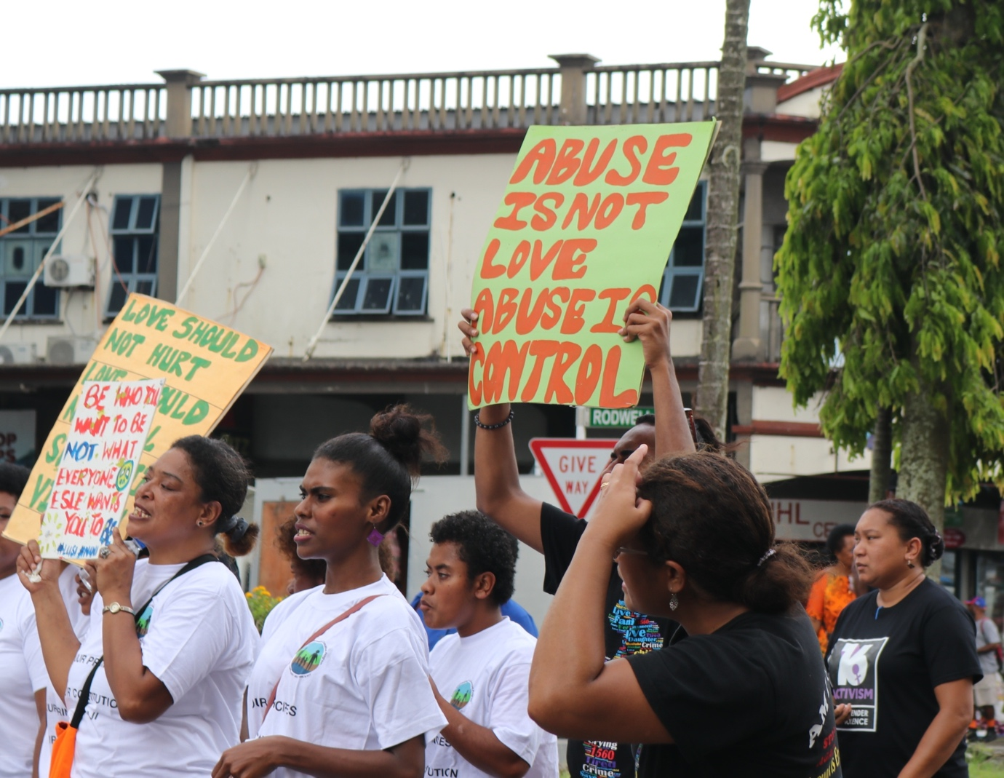

Lessons learned from the Pacific

The following lessons learned reflect the collective knowledge of government and civil society organisations from across five Pacific countries.

Pacific experiences have generated some key lessons which may be useful for other countries in developing their own national service delivery protocol. The following lessons learned reflect the collective knowledge of government and civil society organisations from across the five Pacific countries who were involved at different stages of their country’s SDP development and implementation, and offers an important resource for countries beginning their own process.

- The SDP must have a strong coordination and governance structure, and it is recommended the National Women’s Machineries (i.e. Ministry of Women, Department of Women, etc.) have the primary responsibility for coordination and governance of GBV services. This includes having dedicated personnel or team to coordinate and oversee the development and implementation of the SDP.
- This should be a dedicated position without additional roles and duties as this presents significant challenges to the timely and inclusive development and roll out of the SDP.
- The dedicated position is responsible for coordinating, communicating and providing guidance and direction to stakeholders throughout the entire process.
- The coordinator role should be supported by an advisory group of key stakeholders to guide the process from beginning to end and provide oversight and leadership.
- The advisory group should be the same people throughout the process to ensure consistency and continuity, and should include key members from government, services, and may include development partners and donors.
- The core group should identify a pool of facilitators who will aid the consultation process.
- The coordination and governance structure and position should be appropriately funded.
- The country government should take ownership in establishing and coordinating the governance structures.

- Consult widely with clear and consistent communication.
- Communication on the development process must be consistent and clear, and should include a map of the process so that all stakeholders understand where they are in the process and the way forward.
- All key service providers and community actors should be involved from consultation to finalisation and implementation of the SDP.
- Ensure diverse voices and perspectives are included and heard in the consultation process. People with disabilities, LGBTQI+ people, people from diverse ethnic and cultural backgrounds, people in regional, rural and remote areas, all need to be a part of the consultation. The strength of this diversity will help ensure that the SDP caters to the individual needs of survivors.
- Consider the time factor throughout the whole process and inform service providers of the time commitment at the beginning. Drawn-out processes will risk turn-over in personnel service representation, which impacts on the consistency and continuity of participation and information management.
- It is important to consult across multisectoral agencies, including the justice sector. Gaps in the justice system were frequently identified in the experience of the five Pacific countries. To overcome this, ensure relevant services and agencies across the various sectors are involved in the consultation and have membership in the advisory group.

- Use the SDP consultations to construct a shared understanding of GBV response through training and skills development.
- Foundational knowledge about, and attitude towards, GBV varies between stakeholders and partners, and a strong understanding of GBV is key to secure genuine commitment to the SDP. It is important to construct a shared understanding in the consultation process through agreeing on definitions and providing training on the guiding principles and minimum standards.
- The consultation process must emphasise the core commitments, particularly in relation to confidentiality. Stakeholders must have a unified and shared understanding about confidentiality in order to prioritise survivors’ safety and build trust between stakeholders participating in the SDP process.
- The consultation process provides an opportunity to develop consistency in language and messaging used by service providers to avoid confusion from the public.
- Training and skills development are also key to ensure stakeholders understand the multisectoral approach. This should draw upon outside expertise as well as the expertise and experience of local stakeholders and service providers.
- Ensure continued development of the SDP by planning for disaster and emergency events that may arise during the consultation process and other challenges which could otherwise delay the SDP development and roll-out.

- The SDP must be applicable during emergency and disaster situations.
- The SDP must have an element of flexibility and adaptability so that it can be utilised in disaster and emergency contexts.
- In small countries, such as Pacific nations, the service providers that operate during non-disaster times are the same providers who work during times of disaster. The SDP must recognise that survivors’ needs must be paramount both during disasters and at other times.
- The SDP must have a comprehensive risk management plan to account for disaster and emergency contexts, as service providers will be strained during these times.

- Contextualise the guiding principles and minimum standards so that it is appropriate for the country’s unique context.
- The international background materials drawn upon in the SDP, such as the guiding principles and minimum standards, need to be adapted so that they are workable and purposeful within each country. This may, for example, involve the inclusion of additional principles and/or adapting the definitions.
- Consider the regional and remote contexts within the country and adapt accordingly so that the SDP and local referral pathways are useful and accessible across all regions of the country.
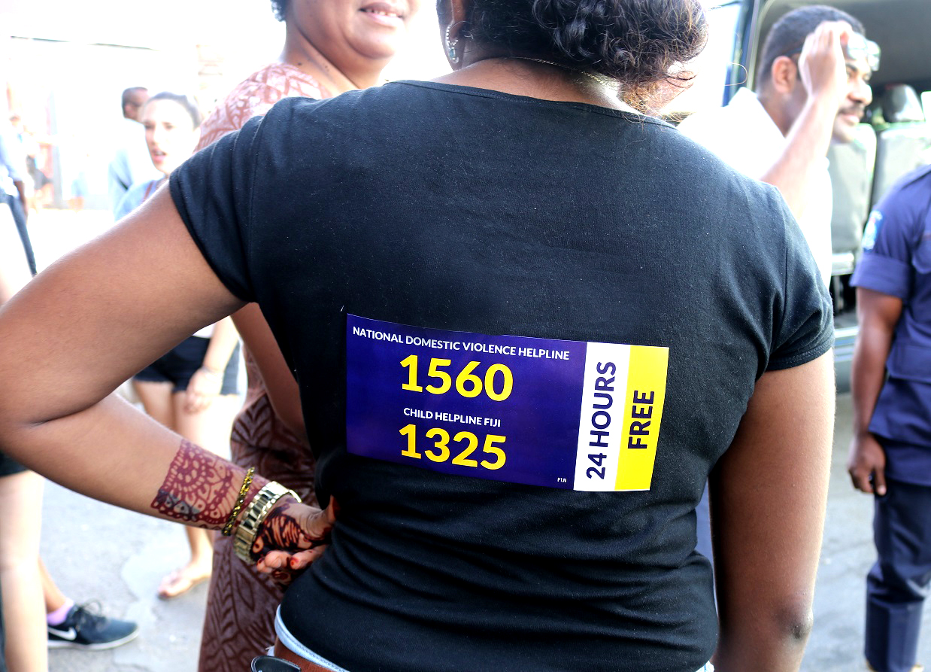

Recommendations

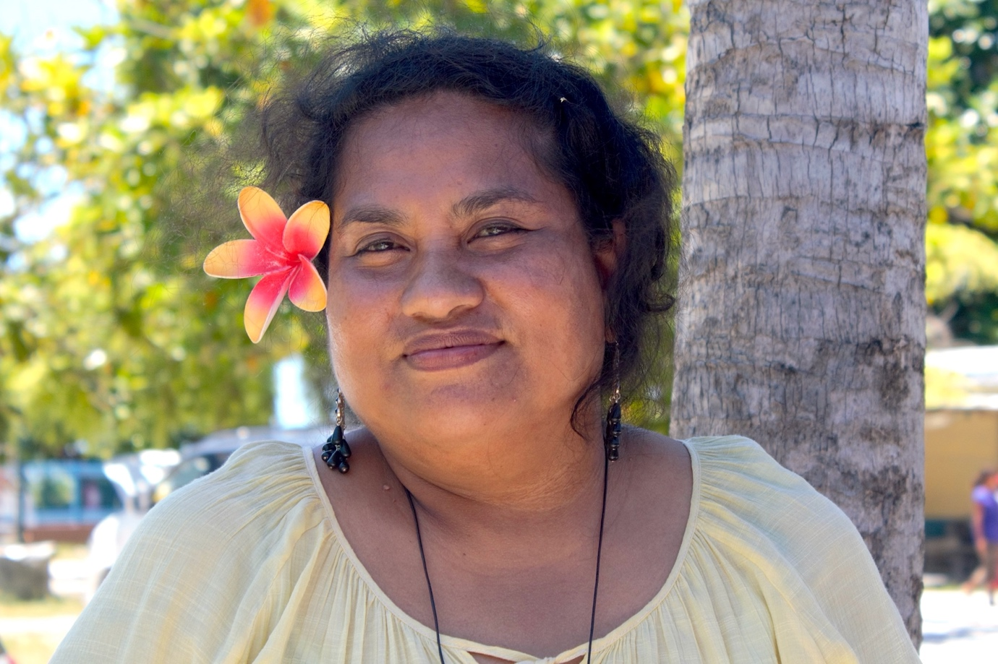

National governments
- Ensure that appropriate legal and policy frameworks are in place to facilitate the development of a service delivery protocol.
- Designate a government ministry and/or agency to coordinate and govern
the SDP process.
- Match the government’s commitment to the development and implementation of the SDP with appropriate, long-term, funding commitments.

Civil society organisations and women’s movements
- Play a central leadership role in specialist GBV prevention training and skills development for other multisectoral agencies and stakeholders.
- Uphold and advocate for a survivor-centred approach, and prioritise the safety of women and children.
- Commit a key person to be part of the advisory group from beginning to end.
- Designate a role responsible for overseeing the development and implementation of internal policies and procedures that align with the SDP guiding principles, minimum standards and referral processes.
- Share key learnings across organisations, movements and countries, to strengthen external processes and create a regional and global community of practice.

Technical partners
- In consultation with the lead agency and advisory group, identify key technical partners and stakeholders and facilitate connections and networks within the country and/or region.
- Identify and recommend experts and consultants who can support the SDP process, particularly for training and skills development.
- Mobilise resources and funding to support the SDP process, recognising that developing and embedding these systems takes, on average, five to ten years.

Donors
- Partner with national governments seeking to embark on their own
SDP process.
- Commit adequate funding to support the SDP development and implementation process, inclusive of support for key leadership and coordination roles, recognising that developing and embedding these systems takes, on average, five to
ten years.

Acknowledgements

Through the Pacific Partnership to End Violence Against Women and Girls (Pacific Partnership), UN Women works with partners to promote gender equitable social norms at individual and community levels to prevent violence against women and girls.
The Pacific Partnership brings together governments, civil society organisations, communities and other partners to promote gender equality, prevent violence against women and girls (VAWG), and increase access to quality response services for survivors. It is funded primarily by the European Union, and the Governments of Australia and New Zealand, and UN Women, and is led by the Pacific Community (SPC), UN Women, and the Pacific Islands Forum Secretariat.
This publication, commissioned by UN Women, was prepared by Dr Chay Brown and designed by Scarlett Thorby-Lister and Catrin Harris (The Equality Institute), with technical guidance and input from Uieta Kaufusi and Abigail Erikson (UN Women).
The brand imagery used for the Pacific Partnership is inspired by empowering female-specific tattoo motifs used in the Pacific.
DISCLAIMER: This publication has been produced with the financial support of the European Union and the Governments of Australia and New Zealand, and UN Women. Its contents are informed by the writers and can in no way be taken to reflect the views of the European Union, Australian Government, New Zealand Government, and UN Women, or any associated organisation.
UN Women MCO and the Pacific Partnership would like to acknowledge the contribution of the following partners:

Fiji | Reijieli Mawa, Ministry of Women, Children, and Poverty Alleviation  Mere Makulau, Ministry of Women, Children, and Poverty Alleviation
Kiribati | Eera Teakai Baraniko,  Ministry of Women, Youth,  Sport, and Social Affairs  Melinda Christopher, Ministry of Women, Youth, and Social Affairs
Samoa | Afamasaga Fa’auiga Mulitalo,  Ministry of Women, Children,  and Social Development  Siliniu Vitalina Chang,  Samoa Victim Support Group
Solomon Islands | Juliana Zutu, Ministry of Women, Children, Youth, and Family Affairs  Merrilynne Pryde, Ministry of Women, Children, Youth, and  Family Affairs
Tonga | A.Polotu Fakafanua-Paunga,  Ministry of Internal Affairs, Women’s Affairs and Gender Equality Division  ‘Aina Kavaliku, Ministry of Internal Affairs, Women’s Affairs and Gender Equality Division  Lavinia Palei, Ministry of Internal Affairs, Women’s Affairs and Gender Equality Division  Tupou Lanumata, Women and Children Crisis Centre (WCCC) Tonga

UN Women Fiji Multi-Country Office (MCO)
Level 3, Kadavu House, Victoria Parade
Private Mail Bag, Suva, FIJI
Tel: (679) 330 1178
Email: comms.pac@unwomen.org

The United Nations Joint Global Programme on Essential Services for Women and Girls Subject to Violence, (2015). Essential Services Package, Module One: Overview and Introduction.
World Health Organisation (2018). Western Pacific Fact Sheets. Violence against women: Global Prevalence Estimates, 2018.
UN Women (2016).Global Database on Violence Against Women. http://evaw-global-database.unwomen.org/en.
Fijian Government (2018). Fiji Naional Service Delivery Protocol for Responding to Cases of Gender Based Violence.
Solomon Islands Government (2017). SAFENET Guidebook 2017: The SAFENET standard operating procedures for referral and coordination of sexual and gender based violence services. Solomon Islands Government.
The United Nations Joint Global Programme on Essential Services for Women and Girls Subject to Violence, (2015). Essential Services Package, Module One: Overview and Introduction.
Fijian Government (2018). Fiji National Service Delivery Protocol for Responding to Cases of Gender Based Violence.
The United Nations Joint Global Programme on Essential Services for Women and Girls Subject to Violence (2015). Essential Services Package, Module One: Overview and Introduction.
Ibid.
Samoa Ministry of Women Community & Social Development (2021). Samoa inter-agency essential services guide for responding to gender-based violence and child protection.
The United Nations Joint Global Programme on Essential Services for Women and Girls Subject to Violence (2015). Essential Services Package, Module One: Overview and Introduction.
Ibid.
Samoa Ministry of Women Community & Social Development (2021). Samoa inter-agency essential services guide for responding to gender-based violence and child protection ; Fijian Government (2018). Fiji National Service Delivery Protocol for Responding to Cases of Gender Based Violence; Solomon Islands Government (2017). SAFENET Guidebook 2017: The SAFENET standard operating procedures for referral and coordination of sexual and gender-based violence services. Solomon Islands Government ; Tonga Ministry of Internal Affairs’ Women’s Affairs and Gender Equality Division (2021). Tonga National Service Delivery Protocol for Responding to Cases of Gender-Based violence: Standard operating procedures ; Government of Kiribati (2018). Kiribati Standard Operating Procedures for Gender-based violence response. Kiribati: UN Women.
Solomon Islands, Kiribati, Fiji, Tonga and Samoa.

