UNCT-SWAP Gender Equality Scorecard Toolkit Resource
What?  Adequate Resources for Gender Mainstreaming are Allocated and Tracked - Good Practice Example: UN Country Team Viet Nam (2020). |  | Why?  This document documents the steps taken by the UNCT in Viet Nam, to accelerate progress on Performance Indicator 6.1, following the UNCT-SWAP Scorecard assessment that identified weaknesses in this performance area.  The process serves as a good practice model for UNCTs seeking to meet the minimum requirements for Performance Indicator 6.1. It includes strategies and lessons learnt through the implementation process.
Performance Indicator 6.1 Financial Resources
Approaches Minimum Requirements | Meets Minimum  Requirements |  | Exceeds Minimum Requirements
a) The UNCT has carried out at least one capacity building event on the UNCT Gender Equality Marker over the current Cooperation Framework cycle. | Approaches minimum requirements  and  b) The UNCT has established and met a financial target for program allocation for gender equality and empowerment of women |  | Meets minimum requirements  and  c) The UNCT has established and exceeded a financial target for program allocation for gender equality and empowerment of women.

Indicator 6.1 | Adequate Resources for Gender Mainstreaming are Allocated and Tracked
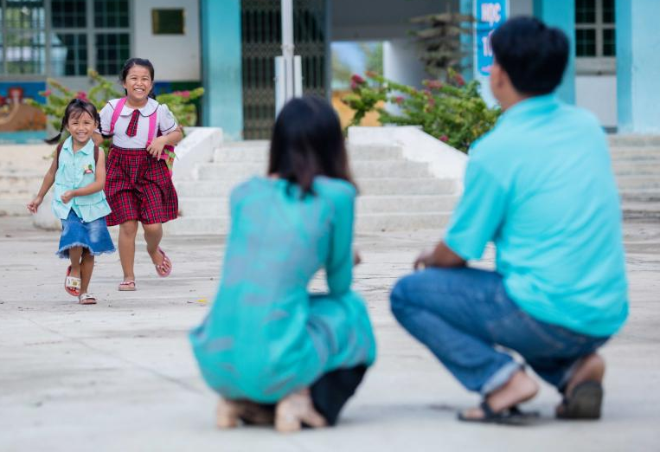

Good Practice Example:

UN Country Team (UNCT) Viet Nam

Acknowledgements: This good practice example was captured and documented by Diana Mamatova with Katy Pullen on behalf of the UN System Coordination Division, UN Women with thanks to UNCT Viet Nam members, particularly the UN Theme Group on Gender, Nguyen Bui Linh, Data Management, Results Monitoring and Reporting Officer in the Resident Coordinator’s Office and Vu Phuong Ly, Programme Specialist, UN Women.
Photo | UNFPA Vietnam 2019/ Nguyễn Minh Đức
Background & Context

As the UNCT in Viet Nam embarked on its 2017 – 2021 UNDAF cycle, attention was given to financial resources in support of gender equality and women’s empowerment (GEWE). This followed evaluation results of the Viet Nam UNDAF 2012 – 2016 and the 2016 UNCT-SWAP Gender Equality Scorecard assessment which recommended development of guidance on how to track planned and actual expenditures on GEWE across all programmes/projects (‘Key Activities’) in the UNCT Joint Work Plan (JWP).

When the UNCT Viet Nam ‘One Strategic Plan’ (2017 – 2021 UNDAF cycle) was developed the UNCT Gender Equality Marker Guidance Note had not yet been published. The UNCT in Viet Nam therefore drew on existing UN gender marker guidance and undertook a consultative process to develop its Gender Equality Marker (GEM) system for 2019-2020 Joint Work Planning. Led by UN Women in close coordination with the Resident Coordinator’s Office (RCO), Programme Management Team, UN Group on Monitoring for Strategic Results and other UNCT members, this guidance was finalized in 2018 with the support of UN Results Groups and relevant Thematic Groups. Many of the key principles and processes outlined in the 2018 UNCT Viet Nam GEM guidance are aligned with – and helped inform – the UNSDG-approved UNCT Gender Equality Marker Guidance Note subsequently released in June 2019.

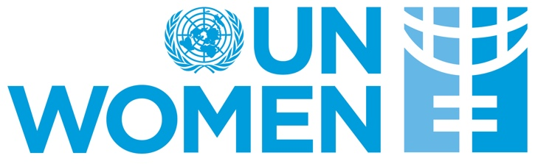

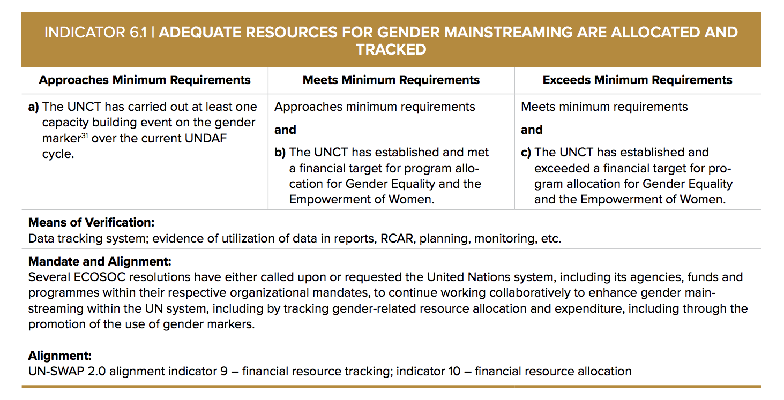
UNCT Viet Nam Action on UNCT-SWAP Performance Indicator (PI) 6.1

In developing its Gender Equality Marker (GEM) system for 2019-2020 Joint Work Planning, the UNCT Viet Nam took steps to accelerate progress on UNCT-SWAP PI 6.1.

The key steps are outlined below alongside tips and strategies identified during implementation.

- Investing in capacity building on the Gender Equality Marker (GEM)

Prior to applying the GEM to Key Activities in the UNCT JWP, UN Women conducted a series of trainings on gender-responsive planning, budgeting and reporting. Delivered to UNCT members, including those belonging to the UN Results Groups, gender focal points, and the Monitoring & Evaluation Group, the training encompassed an introduction to the basic concepts of the GEM, the importance of dialogue during the GEM application exercise, and the proposed UNCT Viet Nam approach to tracking financial allocations for GEWE through the digitized JWP on the UN INFO platform.

Tips and strategies
Strong political will and support for addressing gender equality considerations in UN programming can accelerate progress on UNCT SWAP PI 6.1. The Viet Nam experience highlighted the vital role of the Resident Coordinator and the RCO in promoting GEM application to the UNCT JWP and tracking of program allocations to GEWE. Investing in capacity building on the GEM was a vital first step toward meeting the minimum requirements of this indicator and helped address some of the known challenges of gender markers such as Key Activities being coded at a higher level than they should be (‘over-coding’).

- Establishing a financial target for program allocation to GEWE

The UNCT-SWAP Gender Equality Scorecard 2018 Framework & Technical Guidance does not prescribe a financial target for program allocation to GEWE, stating that “targets are at the discretion of country teams depending on the local context”. The guidance does, however, take note of the Secretary-General target set in 2010 of 15% for UN-managed peace-building funds to be spent on projects that promote GEWE. As part of discussions and preparations for its 2019 – 2020 JWP, the UNCT Viet Nam identified a target of at least 15% of the total expenditure of its programmes to be allocated for GEWE, and added the following two specific requirements:
- At least one Output of each Outcome should be explicitly addressing GEWE as a significant or principal objective, with a minimum 30% of the Output’s total budget allocated to Key Activities that either have GEWE as a significant (UNCT GEM code 2) or principal objective (UNCT GEM code 3).
- One third to half of Output indicators need to be sex-disaggregated and gender-sensitive to be able to track progress towards GEWE (in alignment with meeting minimum requirements for UNCT-SWAP PI 1.3).

Tips and strategies
When discussing a financial target for program allocation to GEWE it is useful for the UNCT to first establish a baseline for current allocations to GEWE. Even if the baseline is an estimate this can help the UNCT set a realistic target and measure progress toward the target over time.

3. Applying the Gender Equality Marker (GEM) to the UNCT Viet Nam Joint Work Plan (JWP)

Having established a financial target for program allocation to GEWE, the next step toward tracking progress on this target was to apply the GEM to all Key Activities in the draft UNCT JWP. During this exercise gender focal points within each of the Results Groups facilitated discussions on GEWE considerations and related GEWE-results paying close attention to GEM coding definitions/criteria. This focus on coding criteria and participatory quality assurance helped Results Groups avoid making assumptions when applying GEM codes thereby mitigating the risk of over-coding. Additional quality assurance was provided by UN Women at the final draft stage. This peer review included an analysis of the budget committed to GEWE and coding per Output/Outcome as well as the overall coding and budget allocation to GEWE across the entire JWP.

Tips and strategies
Human resources and time were identified as the main resources needed to implement the GEM successfully. Applying the GEM to all Key Activities in the UNCT JWP involves capacity building/training, dialogues on GEM coding, and quality assurance support in line with the UNCT Gender Equality Marker Guidance Note. Members of the Gender Theme Group, who often serve as gender focal points in the Results Groups, can provide necessary technical support, facilitate dialogue on GEM coding, and offer guidance on tracking financing for GEWE. Political will and support among UNCT members is also vital in promoting GEM application at both planning and reporting stages. Chairs of the Results Groups, for example, have a key role in creating space for dialogue on GEWE considerations and participatory quality assurance.

4. Leveraging the UN INFO platform to monitor and track progress against the financial target

Once the GEM had been applied to Key Activities in the JWP, UNCT Viet Nam looked to the UN INFO platform to support efforts to monitor and report on progress against the financial target of at least 15% of the total expenditure of programmes to be allocated for GEWE. The RCO created two additional columns in the UN INFO online database template to collect (i) the proportions of the estimated budget and (ii) actual expenditure for GEWE of each Key Activity (see screenshot below). These additional columns to the UN INFO template enable financial data on GEWE across Key Activities of the JWP to be generated at the Outcome, Output, and UN Agency levels. As at December 2020, financing in support of GEWE is being tracked by the UNCT in Viet Nam and reported on annually.

UNCT Viet Nam 2019 – 2020 JWP in UN INFO showing additional columns for tracking financing on GEWE

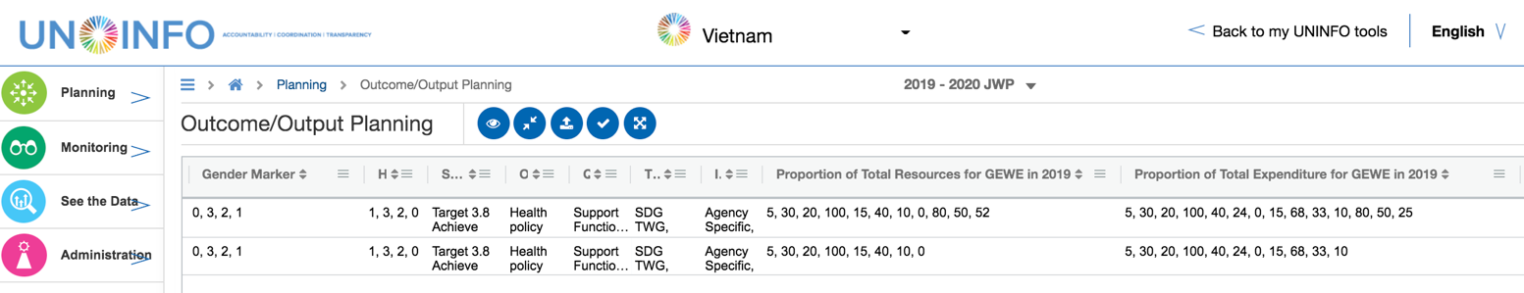

Tips and strategies
The RCO was instrumental in designing relevant UN INFO configuration and accompanying guidance which enable the monitoring and reporting on GEM and financial resources in support of GEWE. In Viet Nam, the GEM is applied and planned financial allocations in support of GEWE are estimated during the annual planning process to inform the UNCT JWP. Actual expenditure amount and percentage of the budget in support of GEWE are estimated toward the end of the year. UN Women has responsibility for reviewing the One UN Annual report to ensure GEWE results are reflected in the report.

Meeting & Exceeding Minimum Requirements on UNCT-SWAP Performance Indicator 6.1

Through the steps described above, the UNCT in Viet Nam is able to calculate approximate budget allocated and actual expenditure on GEWE. This in turn enables the UNCT to track and report annually on progress toward its financial target of at least 15% of the total expenditure of its programmes to be allocated for GEWE.

By the end of 2019, UNCT Viet Nam was able to demonstrate it had exceeded its financial target with 23.5% of the annual JWP budget for 2019 (USD 31,865,631) going toward GEWE considerations at the planning stage and the UNCT achieving an overall 23.04% actual expenditure level of the budget (USD 16,421,095) in support of GEWE at year-end. The table below provides a breakdown of planned and actual UNCT Viet Nam expenditure across Key Activities by GEM code in 2019. Beyond accelerating progress on UNCT-SWAP PI 6.1, the process designed and followed by UNCT Viet Nam has also been instrumental in identifying programming gaps and new opportunities for promoting GEWE across the work of the UNCT.

UNCT GEM Code | UNCT Viet Nam  Planned Expenditure 2019 |  | UNCT Viet Nam  Actual Expenditure 2019
 | % of Key Activities per each GEM code | % of planned budget from total per each GEM code | % of Key Activities per each GEM code | % of actual budget from total per each GEM code
GEM 3 | 0% | 0% | 0% | 0%
GEM 2 | 22.2% | 12.9% | 33.4% | 15.6%
GEM 1 | 44.4% | 7.2% | 33.3% | 2.61%
GEM 0 | 33.4% | 3.4% | 33.3% | 4.83%
% of budget for GEWE (from the total budget) | - | 23,5%  (from the total planned budget of USD 135,546,637) | - | 23,04%  (from the total actual budget of USD 71,282,306)

UN INFO is is an online planning, monitoring and reporting platform that digitizes each Cooperation Framework and its corresponding JWP. In UN INFO the UNCT Gender Equality Marker is a mandatory field in the digitized JWP and must be applied to each Key Activity.

