UNCT-SWAP Gender Equality Scorecard Toolkit Resource
What?  Gender Café encourages women in Cameroon to be politically engaged (2017). |  | Why?  The ‘Gender Café in Cameroon offers a good practice example of coordinated UN system engagement with government and GEWE CSOs to foster gender equality in line with UNCT-SWAP Scorecard requirements for Performance Indicator 3.1 Government Engagement and 3.2 GEWE CSO Engagement.  More information on this good practice is available at: https://africa.unwomen.org/en/news-and-events/stories/2017/08/gender-cafe-encourages-some-in-cameroon
Performance Indicator 3.1 Government Engagement
Approaches Minimum Requirements | Meets Minimum  Requirements |  | Exceeds Minimum Requirements
a) The UNCT has collaborated with at least one government agency on a joint initiative that fosters gender equality within the current Cooperation Framework cycle. | Meets two of the following:  a) The UNCT has collaborated with at least two government agencies on a joint initiative that fosters gender equality within the current Cooperation Framework cycle.  b) The National Women’s Machinery participates in Cooperation Framework consultations: country analysis, strategic prioritization, implementation, M&E.  c) The UNCT has made at least one contribution to substantively strengthen Government participation and engagement in gender related SDGs localization and/or implementation. |  | Meets all of the following:  a) The UNCT has collaborated with at least two government agencies on a joint initiative that fosters gender equality within the current Cooperation Framework cycle.  b) The National Women’s Machinery participates in Cooperation Framework consultations: country analysis, strategic prioritization, implementation, M&E.  c) The UNCT has made at least one contribution to substantively strengthen Government participation and engagement in gender related SDGs localization and/or implementation.
Performance Indicator 3.2 GEWE CSO Engagement
Approaches Minimum Requirements | Meets Minimum  Requirements |  | Exceeds Minimum Requirements
a) The UNCT has collaborated with GEWE CSO and women’s rights advocates on at least one joint initiative that fosters gender equality and empowerment of women within the current Cooperation Framework cycle. | Meets two of the following:  a) The UNCT has collaborated with GEWE CSO and women’s rights advocates on at least two joint initiatives that foster gender equality and empowerment of women within the current Cooperation Framework cycle.  b) GEWE CSO participates in Cooperation Framework consultations: country analysis, strategic prioritization, implementation, M&E.  c) The UNCT has made at least one contribution to substantively strengthen GEWE CSO participation and engagement in gender related SDGs localization and/or implementation. |  | Meets all of the following:  a) The UNCT has collaborated with GEWE CSO and women’s rights advocates on at least two joint initiatives that foster gender equality and empowerment of women within the current Cooperation Framework cycle.  b) GEWE CSO participates in Cooperation Framework consultations: country analysis, strategic prioritization, implementation, M&E.  c) The UNCT has made at least one contribution to substantively strengthen GEWE CSO participation and engagement in gender related SDGs localization and/or implementation.

Gender Café encourages women in Cameroon to be politically engaged
The UN system, led by UN Women, along with the Government and CSO, co- chairs the ‘Gender Café’ national platform that meets every two months. Sectoral ministries, UN system, GEWE CSO and donors all participate in the platform, which is aimed at information sharing, coordination, policy advice, advocacy and networking.
The 12th edition of Gender Café falls within the framework of the 55th edition of the International Day of the African woman.
Date: Thursday, August 10, 2017

Women from all walks of life and those occupying top political and leadership positions in Cameroon have taken the firm commitment to work in synergy and scale up the participation of more women in politics and leadership positions in future elections. They also unanimously agreed that an aggressive sensitization campaign with the media and the economic empowerment of women and young girls at grass root levels can go a long way to increase the low rate of women in political participation and leadership positions in Cameroon.
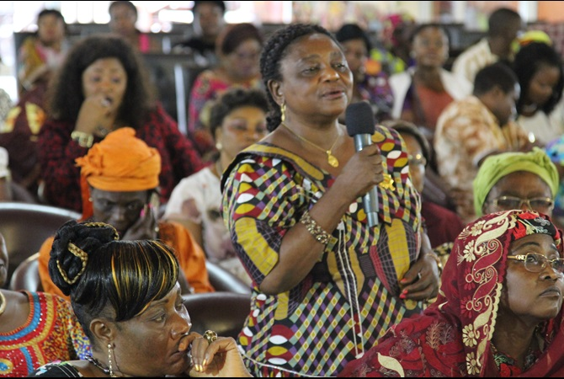
Photo caption: Senator Lafon making her point during the gender café |Photo credit UN Women, Fajong Joseph
These resolutions were made during the 12th edition of Gender Café – a platform for discussion to scale up women’s empowerment and gender equality in Cameroon on 27 July 2017 in Yaounde.

The event which was jointly organized by the United Nations Entity for Gender Equality and the Empowerment of Women Cameroon and the Ministry of Women’s Empowerment was held under the theme “Women and politics: ways and means of ensuring the full participation of women through free, equitable and gender sensitive elections.”

Speaking during the dialogue, the Resident Representative of UN Women Cameroon, Adama Moussa said, “UN Women is engaged in increasing women in leadership positions and political life of the country. We want to have more female candidates in the list of political parties in Cameroon.”

The Minister of Women’s empowerment Pr. Marie Thesres Abena Ondoa, aforesaid everyone has a key role to play in ensuring that more women participate in politics. “We are moving slowly but steadily, we are asking for the support of everyone including men and boys, civil society organizations and development partners to support women in this area,”Marie Thesres explained.

The Gender Café which brought together members of Governments, Senators, Members of the National Assembly, political and traditional leaders as well as the Civil Society Organizations reviewed the current state of women in politics and leadership positions through panel presentations and discussions.

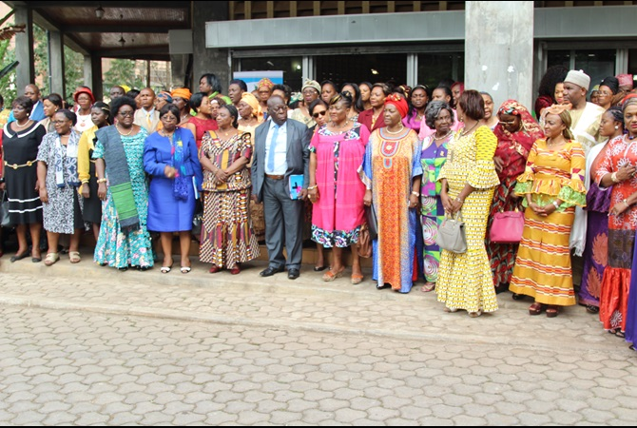
Photo caption: Participants at the Gender Café in Yaounde |Photo credit: UN Women, Fajong Joseph

Source: https://africa.unwomen.org/en/news-and-events/stories/2017/08/gender-cafe-encourages-some-in-cameroon

