Organizing Resources (Means of Verification) for UNCT-SWAP Scorecard Assessment
Developed for UNCT-SWAP Scorecard Toolkit, 2020
Scoring for the 15 Performance Indicators of the UNCT-SWAP Gender Equality Scorecard against UNSDG minimum requirements requires evidence-based analysis to justify ratings. Suggested Means of Verification (MOV) are outlined in the Technical Guidance for each Performance Indicator. Coordinators can support the Interagency Assessment Team (IAT) to undertake analysis by collecting some of the resources (means of verification) required in advance of the assessment, allowing team members to contribute additional resources during the assessment process.
Some teams have created online shared folders to organize and share evidence between the IAT. Shared sites may be retained to support annual progress reporting. The Pacific Multi-Country Office coordination team (UN Women, UNFPA and RCO) developed a shared Google Drive site to support the comprehensive assessment in 2020, including folders to upload evidence for each Performance Indicator as shown below.
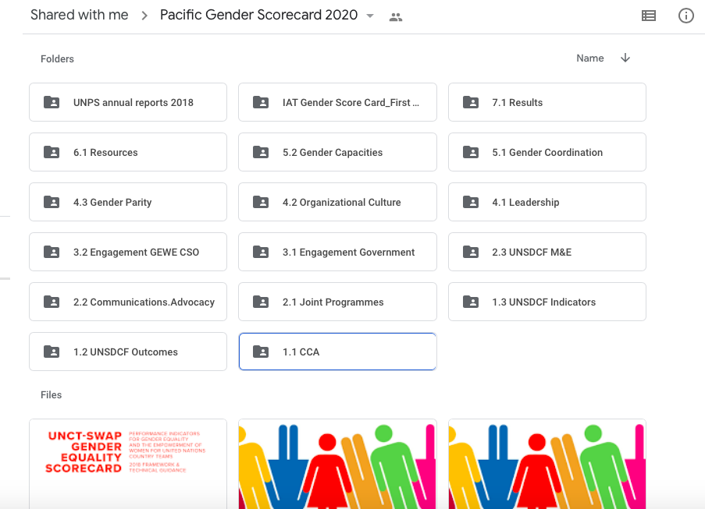

Another means of tracking resources in a table format to inform document collection and identify gaps in information was developed by the RCO Sri Lanka to support the comprehensive assessment in 2020. See framework below. This allowed the IAT to understand at a glance what was readily available and what required additional efforts to ascertain evidence. Furthermore, comprehensive resource tracking facilitates the entering and update of Performance Indicator scores on IMS by the RCO by ensuring all MOVs were well identified and accessible.
Sample Tracking of Resources Available for UNCT-SWAP Assessment
 | Indicator | Means of Verification | Availability | Alternative if not available | Indicator Group | Remarks
1 | Planning
1.1 | Common Country Analysis integrates gender analysis | CCA Documents | ✔ | - | 1
1.2 | Gender equality mainstreamed in UNDAF outcomes | UNDAF Document | ✔ | - | 1
1.3 | UNDAF indicators measure changes on gender equality | UNDAF Results Framework | ✔ | - | 3
2 | Programming and M&E
2.1 | Joint Programmes contribute to reducing gender inequalities | Joint Programme documents;  IMS,  RCAR,  screening tool or other documentation of internal review processes for JPs | ✔  (some) | Documents for joint programmes listed in IMS - available  (PBF projects, SDG ISP, JPP)  RCAR/ 2019 Annual Results Report – available | 1, 3 | Cluster to confirm no screening tool
2.2 | Communication and Advocacy address areas of gender inequality | UNCT current annual workplan  Knowledge products,  Media coverage  Advocacy materials and background evidence of joint planning or funding (eg: meeting minutes, evidence of joint funding commitments in meeting minutes or accounting files) | ✔  (some) | UNCT workplan – not available | 2 | Advocacy materials and KPs need to be collected as evidence
2.3 | UNDAF Monitoring and Evaluation measures progress against planned gender equality results | UNDAF reviews (annual, mid-term and/or final)  Results matrix monitoring data  Training schedule and outline of contents  List of participants |  | UNDAF reviews – not available  Results matrix monitoring data – not available. | 3 | UNDAF level M&E activities not yet carried out; evidence of M&E group gender training?
3 | Partnerships
3.1 | UNCT collaborates and engages with Government on gender equality and the empowerment of women | Documentation materials of UNDAF processes including CCA contributors, participants at planning retreat, and M&E reviews, JP project document  Advocacy materials that include contributors’ names and/or evidence from planning meetings such as minutes  Gender knowledge product  Training or other capacity development documentation such as materials and participants list | ✔  (some) | List of participants at:  UNCT retreat  Strategic Prioritization retreat  CCA consultations  PBF Board meetings  SDG tracker related documents  SDG fund proposal approval from Govt  Trainings/workshops conducted by UN Women, UNICEF, UNFPA | 4 | Cluster members to gather further materials; consult also with Indicator 2.1 and 2.2
3.2 | UNCT collaborates and engages with women’s/gender equality CSO | JP project document  Advocacy materials that include contributors’ names and/or evidence from planning meetings such as minutes  Gender knowledge product  Budgets, training or other documentation of CSO engagement in GEEW SDG localization  Documentation materials of UNDAF processes including CCA contributors, participants at planning retreat and M&E reviews | ✔  (some) | List of participants at:  UNCT retreat  Strategic Prioritization retreat  CCA consultations  PBF Board meetings | 4 | Cluster members to gather further materials; consult also with Indicator 2.1 and 2.2
4 | Leadership and Organizational Culture
4.1 | UNCT leadership is committed to championing gender equality | UNCT HOA meeting minutes for past 12 months  ARC  RC/UNCT annual reports  RC speeches or communications that champion GE  Results from organizational culture and gender equality survey | ✔ | UNCT meeting minutes for past 12 months – available to RCO  RC speeches and comms – available to RCO  Survey results available | 6 | ARC – no longer in use – consider alternatives
4.2 | Organizational culture fully supports promotion of gender equality and the empowerment of women | Survey results | ✔ | Results available | 5
4.3 | Gender parity in staffing is achieved | Consolidated, sex-disaggregated staffing data  Human resource plan  BOS | ✔  (some) | Data to be requested from OMT Check if BOS available from OMT | 5
5 | Gender Architecture and Capacities
5.1 | Gender coordination mechanism is empowered to influence the UNCT for GEEW | Meeting minutes, membership list  GTG TOR and AWP  UNDAF planning and monitoring documentation  UNDAF annual reports, RC/UNCT annual reports | ✔ | GTG related documents available  AWP available – not updated  UNCT annual report 2019 available | 2
5.2 | UNCT has adequate capacities developed for gender mainstreaming | Schedule and participants list from workshop/event  Capacity assessment, capacity development plan, induction package materials |  |  | 2 | Cluster to ascertain if joint capacity development has occurred
6 | Resources
6.1 | Adequate resources for gender mainstreaming are allocated and tracked | Capacity building on UNCT GEM  Data tracking systems  Evidence of utilization of data in reports, RCAR, planning, and monitoring |  | SDG Tracker? | 6 | Cluster to check if GEM capacity building occurred
7 | Results
7.1 | UN Programmes make a significant contribution to gender equality in the country | UNDAF annual reviews, evaluations, results tracking, national data from government statistical offices, MDG/SDG monitoring, CEDAW or BPfA monitoring, WEF, GDI and or GII monitoring |  | SDG tracker  CEDAW/BPfA – OHCHR/UN Women ? | 3

Sample is based on a table produced by the RCO Sri Lanka in preparation for the UNCT-SWAP assessment in 2020.

