UNCT-SWAP Gender Equality Scorecard Toolkit Resource
What?  Good Practice Country-Specific Website and Resources on PSEA  (Myanmar Information Management Unit) https://themimu.info/sector/protection-sexual-exploitation-abuse-psea |  | Why?  The UNCT in Myanmar created a website to support integration of PSEA standards and practices into recruitment processes in line with UNCT-SWAP Scorecard requirements for Performance Indicator 4.2.  The website includes the key documents, resources and tools of the PSEA Network, which has been established in Myanmar to carry out operational functions for the protection against sexual exploitation and abuse.  A checklist is included, to provide guidance to Human Resources personnel, managers and/or others involved in recruitment, induction and performance management.  For more on this, please go to: https://themimu.info/sector/protection-sexual-exploitation-abuse-psea  This good practice is in line with Performance Indicator 4.1 (criteria b and c), to facilitate leadership commitment to the advancement of the PSEA principles in the country.
Performance Indicator 4.2 Organizational Culture
Approaches Minimum Requirements | Meets Minimum  Requirements |  | Exceeds Minimum Requirements
Survey results of personnel perception of organizational environment for promotion of gender equality scored a positive rating of 50-64 percent. | Survey results of personnel perception of organizational environment for promotion of gender equality scored a positive rating of 65-80 percent. |  | Survey results of personnel perception of organizational environment for promotion of gender equality scored a positive rating of over 80 percent.

Good Practice Country-Specific Website and Resources on PSEA
The United Nations Myanmar Information Management Unit (MIMU) has developed an online site resource page on Prevention of Sexual Exploitation and Abuse (PSEA) that includes resources in English and Burmese.
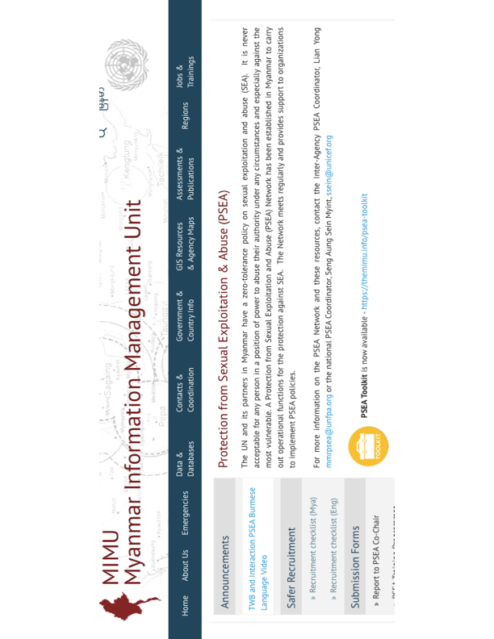
Opening Page: The UN and its partners in Myanmar have a zero-tolerance policy on sexual exploitation and abuse (SEA). It is never acceptable for any person in a position of power to abuse their authority under any circumstances and especially against the most vulnerable. A Protection from Sexual Exploitation and Abuse (PSEA) Network has been established in Myanmar to carry out operational functions for the protection against SEA. The Network meets regularly and provides support to organizations to implement PSEA policies.

Contents: The site offers announcements, resources and useful links, including the following:
- PSEA Focal Points Contact Information
- PSEA Toolkit
- PSEA Network Information
- PSEA Network Resources and Tools
- Sexual Harassment in the Workplace Resources
- PSEA Training Programmes
- Organizational PSEA Assessments
Refer to site for full details and access to resources: http://themimu.info/sector/protection-sexual-exploitation-abuse-psea

