

**UNCT India Implementation Plan for**

**UNCT-SWAP Scorecard 2020**

**Key Highlights of UNCT-SWAP**

The UNCT-SWAP Scorecard is a rapid self-assessment tool that measures the effectiveness of gender mainstreaming at the country-level in the UN system. The 2018 Quadrennial Comprehensive Policy Review (QCPR) and the 2018 ECOSOC Resolution on gender mainstreaming also call for acceleration of UN efforts to mainstream gender and using the Scorecard. At the country-level, the Scorecard is an attempt to summarise the strengths and weaknesses of the UN System in addressing gender equality, both within its own institutional practices as well as in its contribution towards achieving gender equality in the country. The Scorecard is an accountability framework that promotes improved planning, coordination, programming and results for GEEW at the country level, tied to support to Member States to achieve the SDGs. It is focussed on the performance of the UNCT, rather than the performance of a single UN agency, intending on providing an assessment of the UN as a whole.It is recommended the UNCT-SWAP Scorecard be undertaken during the planning stage of a new UNDAF to allow findings to feed directly into the new program cycle. It will be followed by an annual updating report of progress of the implementation of the UNCT-SWAP Scorecard indicators, with the understanding that some indicators will remain unchanged during the UNDAF cycle.

**India’s UNCT-SWAP in 2017**

UNCT India was selected as one of the five countries to pilot the UNCT-SWAP Scorecard, along with Ukraine, Egypt, Iraq, and Vietnam. The scorecard piloting process was undertaken between November 2016 to mid- January 2017. The results showed that the UNCT was the strongest in the areas of communication, knowledge generation and partnerships, and also scored well in the areas of leadership and organizational culture, gender architecture and capacities, and country-level results. Significant improvement was required in the areas of M&E, capacity development, and resource tracking and allocation.

**Proposed UNCT-SWAP in India in 2020**

The UNRC in India had received communication in October 2019 from the UN Women Executive Director, Ms. Phumzile Mlambo-Ngcuka, requesting a progress report on further implementation of the scorecard and any developments in the action plan. Hence the UNCT-SWAP Assessment is overdue. Requesting key advice and decisions on:

* Constitution of an Inter-Agency Team, co-chaired by UNFPA and UN Women (In 2016, a fourteen-member inter agency team was constituted with membership from UNFPA, UNDP, ESCAP, UNICEF, UN Women, RCO)
* The scorecard needs to be endorsed at the highest levels of the UNCT, to ensure effective implementation and follow up supported by senior managers. It needs to be an agenda item during UNCT discussions wherein the objective and scope of the exercise can be discussed, including how it will support improved UNCT programming. Methodology and timeline for the assessment can also be discussed.
* Given the current context of COVID-19, it would also be good to highlight our work on gender equality while engaging with the government and the civil society as part of our health and socio-economic response, in addition to the indicators on integration of GEEW in CCA and UNDAF outcomes. We could also check the impact of COVID-19 on the organizational culture through the proposed survey.

Please find below a suggested implementation plan for the UNCT-SWAP 2020 assessment.[1]

|  |  |  |
| --- | --- | --- |
| **Proposed Action Point** | **Proposed Responsibility** | **Proposed Timeline** |
| Constitution of an Inter-Agency Team, finalization of the objectives, scope, proposed outcomes and methodology for the SWAP exercise.  Suggested composition for the Inter-Agency Team – 8 to 12 representatives from:   * Resident Coordinator Office * Gender Theme Group or other gender coordination mechanism * Communications Group * Monitoring and Evaluation Group * Human Resources/OMT   * For suggested division of labour as per SWAP guidelines, kindly see Annex 2 | Co-chaired by UNFPA and UN Women | By 20th June 2020 |
| SWAP assessment plan endorsed by the UNCT  * Suggested implementation plan provided in Annex 3 | UNCT/RCO | By 30th June 2020 |
| Self-assessment of UNCT’s performance against minimum GEEW requirements, including an organizational survey  (The findings from the organizational survey will also support the integration of PSEA into COVID-19 response) | Inter-Agency Team | By 15th July 2020 |
| Sharing of results and action plan with UNCT  * Scorecard indicator template in Annex 4 | Co-chaired by UNFPA and UN Women | By 25th July 2020 |
| Final UNCT Action Plan for improving Gender SWAP indicators  * Action Plan template in Annex 5 | Inter-Agency Team supported by RCO | By 10th August 2020 |
| UNCT Follow up on progress in Gender SWAP indicators | UNCT/RCO | Last week of November 2020 |

# **ANNEXURE 1 - Areas for Improvement as per the communication from UN Women Executive Director in December 2019**

* Developing targeted training on gender equality based on a gender capacity assessment, and reviewing UNDSS training material to ensure its gender sensitivity;
* Integrating UNCT-SWAP Scorecard guidance in the UNSDCF roll-out;
* Developing a Gender Equality Strategy to mainstream gender across UNSDCF outcome areas, identifying key gender outputs, activities and indicators;
* Developing a Terms of Reference (ToR) for the Monitoring and Evaluation (M&E) Group that clearly defines its responsibilities towards ensuring gender sensitivity in joint M&E frameworks, and incorporating responsibilities regarding gender sensitive M&E in the ToR of the UNSDCF Results Groups more clearly.

|  |  |
| --- | --- |
| BOX 1: Areas for Improvement as per desk analysis conducted for 2019 IMS Reporting | |
| Common Country Analysis   * Gender analysis for all outcome areas * Consistent sex-disaggregated and gender sensitive data * Targeted gender analysis of those furthest behind | Joint Programs   * Gender equality visibly mainstreamed into all Joint Programs * A system to ensure gender mainstreaming in all Joint Programs |
| Communication and Advocacy   * Joint Advocacy Campaign with single messaging on Gender Equality and Empowerment of Women * UNCT collaboration for communication or advocacy in at least one non-traditional thematic area (such as trade and macro-economy; infrastructure; climate change adaptation and/or disaster risk reduction; violent extremism; gender identities, masculinities and sexual orientation.) | UNSDF M&E Framework   * Technical training on gender sensitive M&E of the M&E group at least once in the ongoing UNSDF cycle |
| Organizational Culture   * Survey results for personnel perception of organizational environment for promotion of gender equality should score a positive rating over 80% (2018 survey recorded 70% positive rating) | Gender Parity   * UNCT demonstration of positive trends towards achieving parity commitments * Business Operations Strategy includes gender-specific actions and indicators in at least one Business Operation area to foster GEEW |
| Capacities for Gender Mainstreaming   * Capacity Development plan based on an inter-agency capacity assessment at least once per UNSDF cycle with targets being on track * UNCT Induction Material to include GEEW related commitments and related development challenges of the country | Financial Resources   * At least one capacity building event on Gender Marker during the current UNSDF cycle * Financial target for program allocation for GEEW |

# **ANNEXURE 2 - Proposed Division of Labour for Inter-Agency Team in SWAP Technical Guidance**

# **ANNEXURE 3 - Proposed Implementation Plan in SWAP Technical Guidance**

# **ANNEXURE 4 - Scorecard Indicator Reporting Template as suggested in the SWAP guidelines**

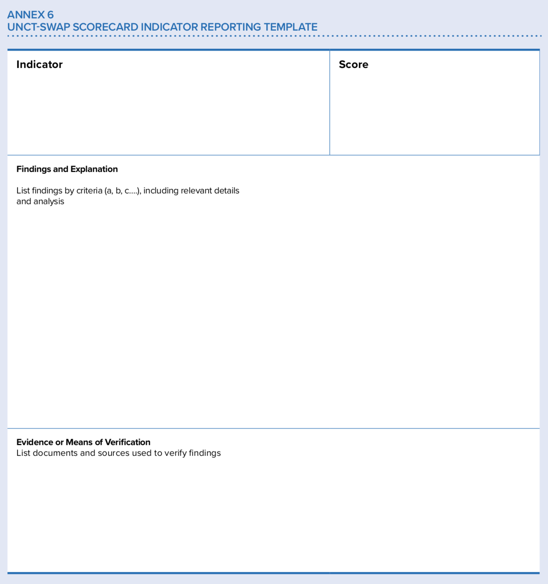

# **ANNEXURE 5 - Action Plan Template as suggested in the SWAP guidelines**

1. Action points have been postponed till 2021 due to the global COVID-19 pandemic and repurposing of all resources towards response actions.