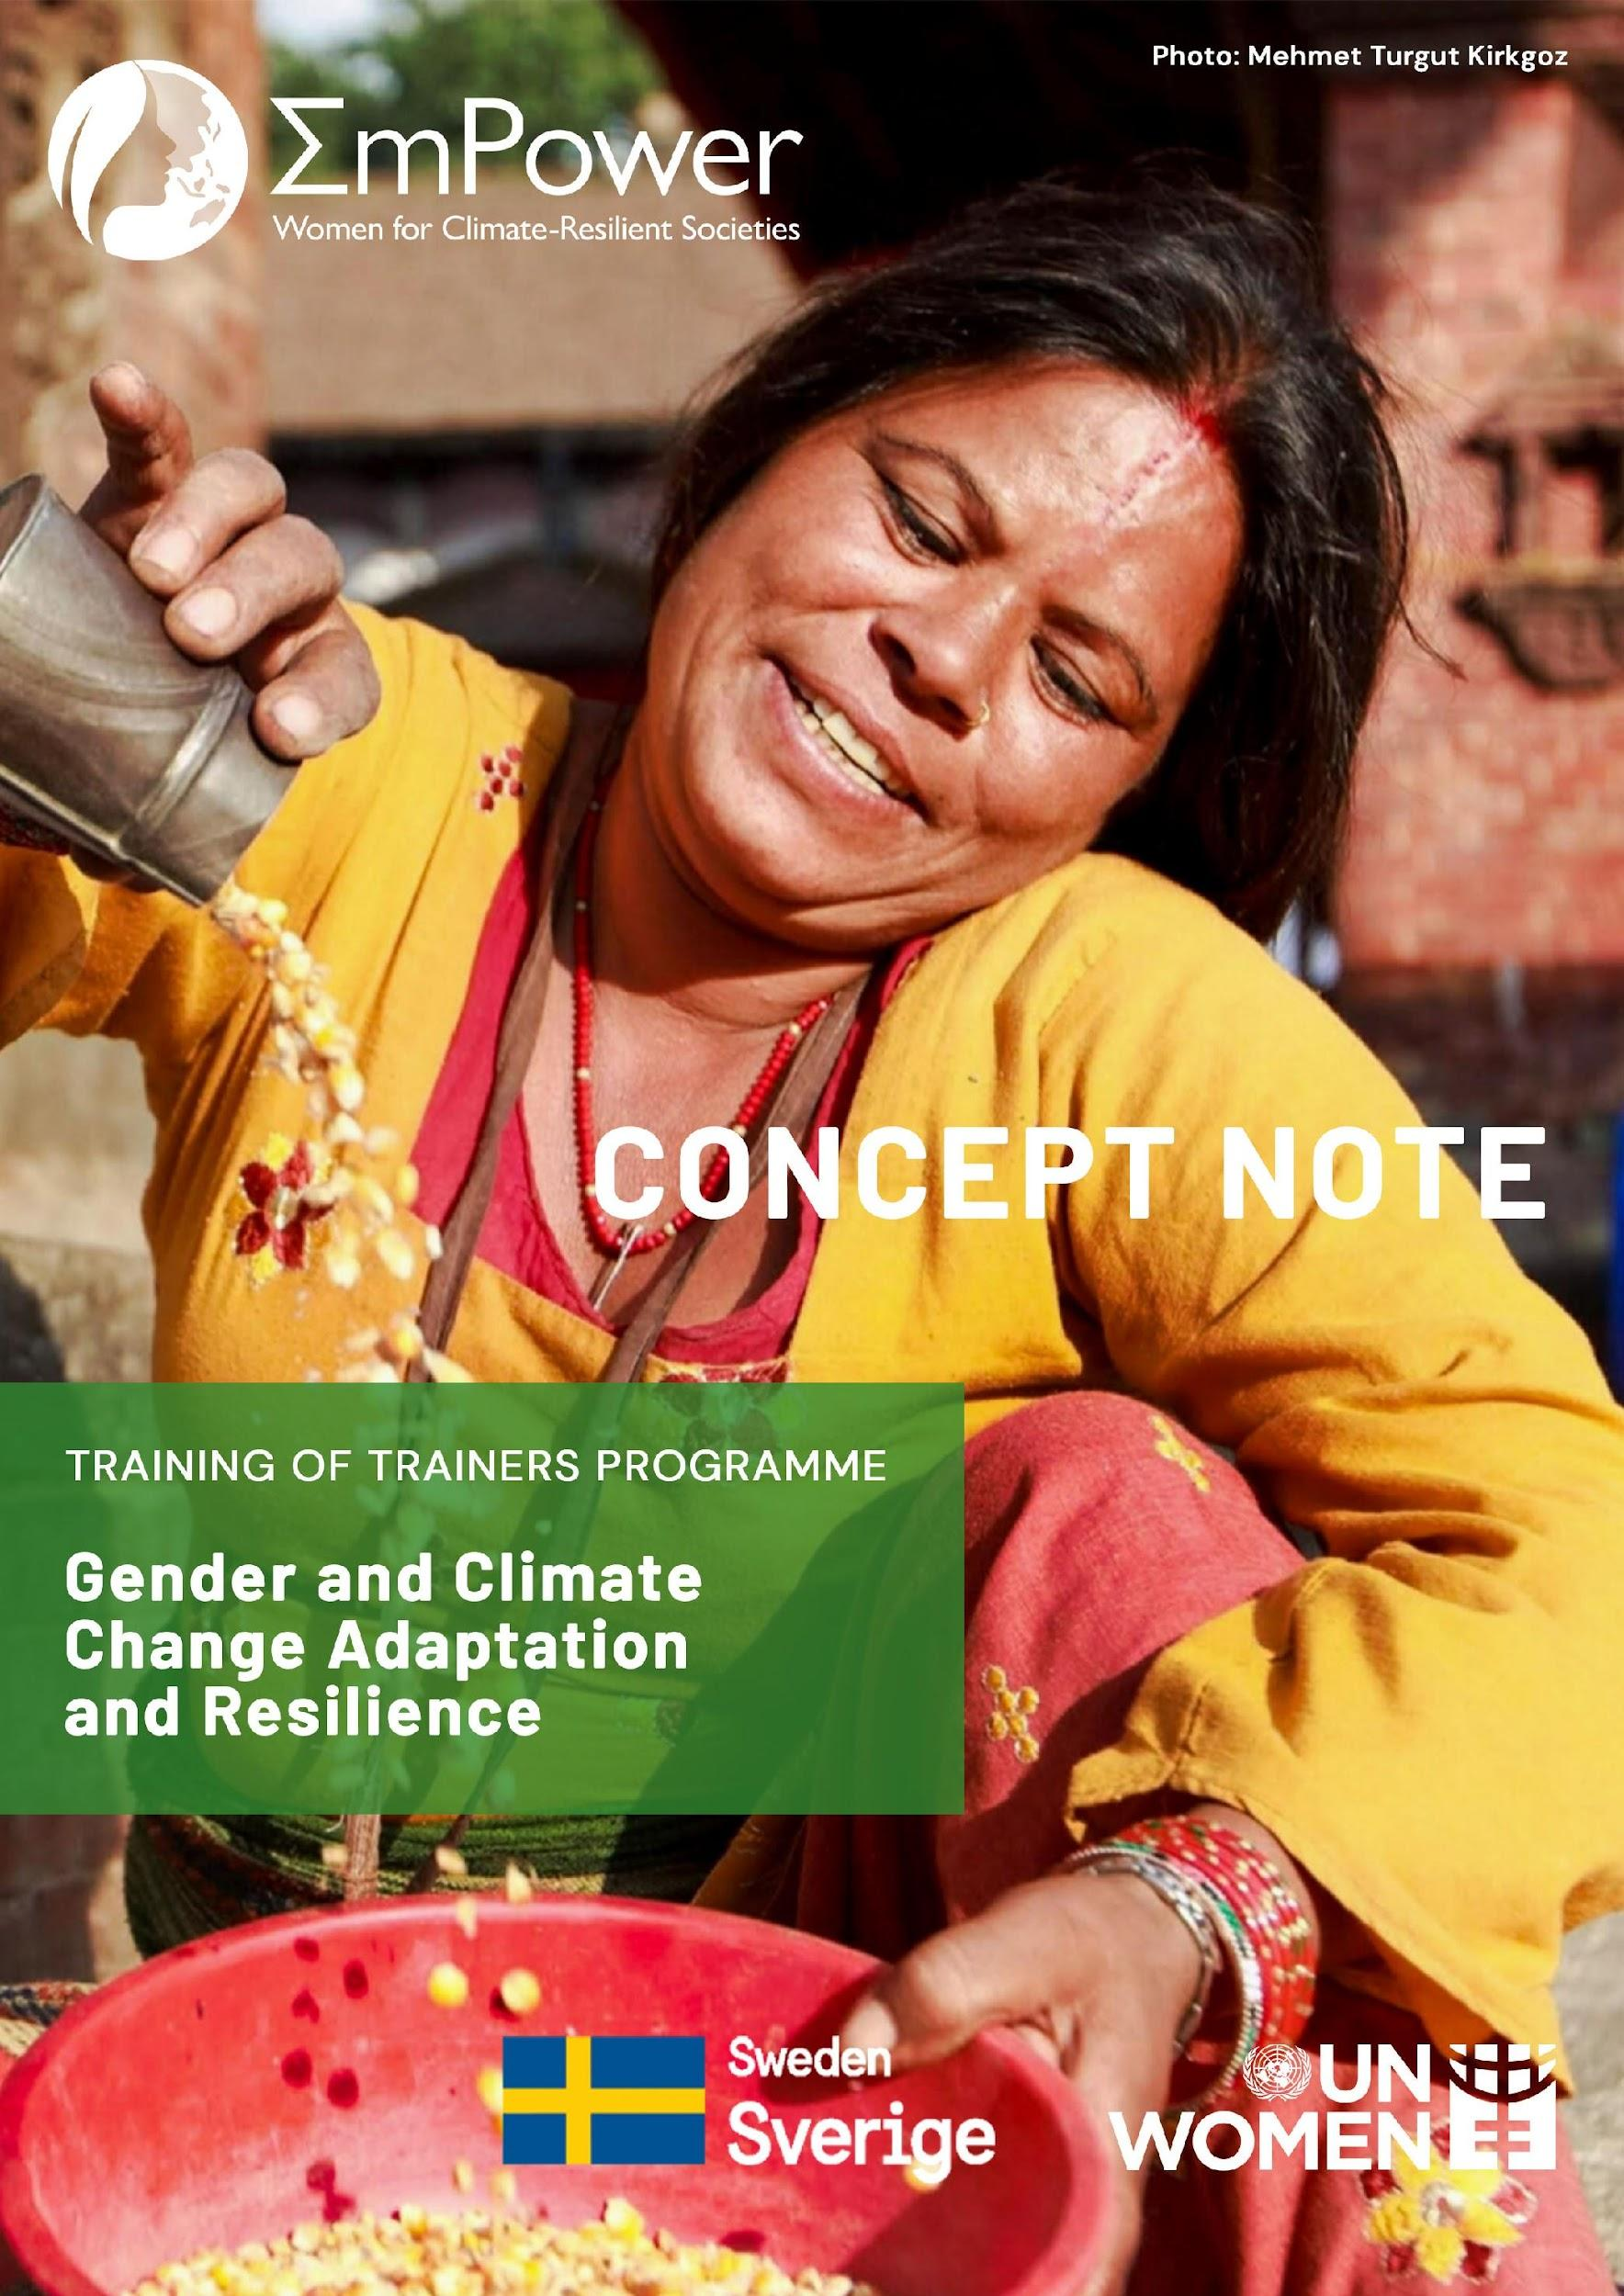

Concept Note on Online Training of Trainers (ToT) Programme on Gender and Climate Change Adaptation and Resilience

Background
Mainstreaming gender equality in climate change is especially relevant for the Asia-Pacific, which is one of the most vulnerable regions to climate change impacts and disasters in the world. Women and girls in the region already suffer from existing gender inequalities, which consequently increase their vulnerability to climate change impacts. Not only will it impact their livelihoods, which is often based on climate-sensitive agriculture and natural resource sectors, their time poverty will increase due to the increased burden on the care economy. Furthermore, when disasters hit, women and girls will suffer more from human rights violations and gender-based violence. It is important to incorporate these gender considerations and gender-responsive approaches in the planning and implementation of climate change resilience and disaster risk reduction (DRR). Unfortunately, women have been largely missing in climate action when it comes to climate negotiations and national planning processes. Women’s capacities, skills, and knowledge for effectively addressing climate change and reducing disaster risks are still untapped, further compromising their ability to adapt to climate change and disasters.

Civil society organizations (CSOs) have an important role to play in making this a reality. CSOs not only have a strong grassroot connection but are suitably placed to analyse the gender gaps and inequalities in society and connect this to climate change, and disaster risk reduction policies and programmes. However, they experience many capacity barriers in gender mainstreaming, either in their project level activities or in advocating for it at local and sub-/national levels. Fulfilling these capacity gaps from the end of CSOs can strengthen the linkages between mainstreaming at different levels, and also present a more effective grassroots picture of local problems during policy formulation at all levels.

The EmPower Project
UN Women is strongly committed to promoting women leadership and empowering CSOs for mainstreaming gender in climate change resilience and disaster risk reduction. A key initiative in this regard is the “EmPower: Women for Climate–Resilient Societies”, a 5-year project (2018-2022) implemented jointly by UN Women and UN Environment in Bangladesh, Cambodia, Viet Nam and regionally in Asia and the Pacific, with the support of the Swedish International Development Agency (EmPower website). EmPower envisions women and marginalized groups in Asia and the Pacific becoming more resilient to the adverse impacts of climate change and disasters. EmPower aims to strengthen gender equality and human rights in climate change and disaster risk actions in Asia and the Pacific region. To achieve this outcome, EmPower has invested in five output areas of: 1) women’s leadership, 2) gender statistics for decision-making, 3) gender-responsive climate change policies 4) renewable energy for resilient livelihoods, and 5) regional engagement.

Training of Trainers (ToT) on Gender and Climate Change Resilience
As part of EmPower’s work on women’s leadership development and CSO capacity building, in 2020, UN Women partnered with ARROW to develop a Training Manual on Gender and Climate Resilience (manual link). Using the materials from this manual, six online Trainings of Trainers (ToTs) for representatives of CSOs were organised in 2021 in Bangladesh, Cambodia, Viet Nam, Thailand, Nepal, and The Philippines. UN Women now aims to amplify the impact of the capacity building work through promoting more ToTs across the region.

Objectives
The purpose of the ToT programme is to strengthen the capacities of CSOs to mainstream gender in their work related to climate change and disaster risk reduction and to actively advocate with the government for gender mainstreaming on policies, programmes, projects, and legislation. Towards this, the ToT will focus on achieving the following objectives:
- Enhance the understanding of interlinkages between gender, human rights, and climate change;
- Build the skills and capacities on gender analysis and gender mainstreaming in projects; and
- Identify strategies and entry points for CSOs to engage with national climate change and disaster risk reduction policies and planning processes.

Target Audience
Representatives of around 20 CSOs working at the national, provincial, and local levels are expected to participate in the ToT. Participants should have a basic understanding of gender and social inclusion or climate change concerns and should be working on the issues. Participants should also have the ability to lead further trainings and engage with government and regional bodies in climate change and DRR discourse by trainings on using the training manuals.

Nomination
A detailed baseline and needs assessment survey (including technology skill mapping) should be conducted before the ToT in order to design a programme more suited to the needs and capacities of the participant group. All organisations are thus requested to nominate one or two participants in advance and fill in the attached baseline survey form so as to plan a more customised ToT programme.

Online Content and Format
The ToT would be a three-day programme with around 4 hours per day. Each day will include two sessions focusing on the following:
- Importance of gender equality in the context of Human Rights Based Approaches (HRBA), and Leave No One Behind (LNOB)
- Gender dimensions of climate change adaptation and disaster risk resilience (DRR)
- Integration of gender in climate change adaptation and DRR policies, programme planning, and budgeting
- Monitoring and Evaluation framework in gender mainstreaming in climate change and DRR (CCDRR)
- Global CCDRR frameworks its linkage with the national policy landscape
- Role of CSOs in mainstreaming gender in climate change policies and plans

Note: The ToTs would be in a complete virtual modality, considering the current situations of the COVID-19 pandemic. The sessions have been designed using mixed methodology tools-lecture/PowerPoints presentations, video documentaries, participatory tools, and group discussions.

Expected learning outcomes
- Better understanding of human right based approach (HRBA), leave no one behind (LNOB), social inclusion, gender equality, and intersectionalities
- Fundamentals of climate change, risks, and vulnerabilities and the need for a human rights based approach
- Ability to recognize and establish linkages among climate change impacts and gender-differentiated vulnerabilities
- Realizing gender implications of climate change in select sectors
- Understanding the tools and frameworks at hand for mainstreaming gender in different phases of the project cycle
- Orientation to local area-based and community-led adaptation planning approaches and application of strategies for gender responsive action
- Understanding the international architecture for CCDRR and the gender mandates
- Ability to link the international mandates with national climate change policies and plans
- Identification of entry points for CSOs to mainstream gender within the national planning processes

Programme Dates and Time

