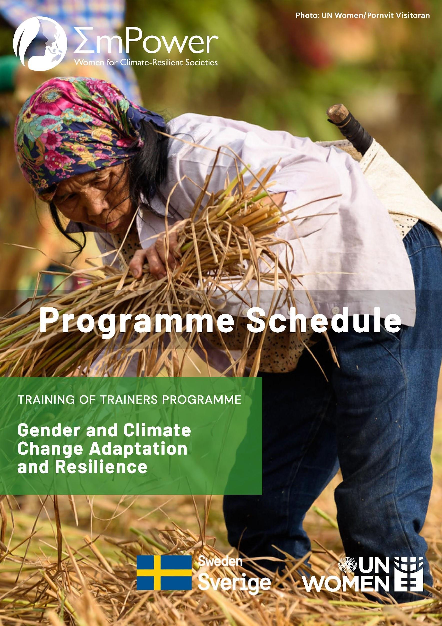
Programme Schedule, (DD/MM/YY)

Day 01: DD/MM/YY

Introductory Session
(9.00 am - 9.45 am)
Time Slots | Duration | Activities | Facilitator
9.00 am – 9.05 am | 05 minutes | Welcome Address
9.05 am – 9.15 am | 10 minutes | Guiding norms and practical information for the workshop (including online etiquette)
9.15 am – 9.25 am | 10 minutes | Participants self-introduction and expectation sharing
9.25 am – 9.35 am | 10 minutes | Opening remarks on “Gender in Climate Change and Disaster Risk Reduction (CCDRR)”
9.35 am – 9.40 am | 05 minutes | Overview of the programme:  Agenda and objective sharing
9.40 am – 9.45 am | 05 minutes | Pre-test (using Google forms)

Session 01: Human Rights and Climate Change
(9.45 am - 11.15 am)
Time Slots | Duration | Activities | Facilitator
9.45 am – 10.15 am | 30 minutes | Presentation 01: Human Rights, Human Rights Based Approach (HRBA), Leave No One Behind (LNOB), Social Inclusion, Gender Equality and Intersectionality
10.15 am – 11.00 am | 15 minutes | Video Documentary 01: Importance of HRBA, LNOB and Gender Equality in context of Sustainable Development Goals (SDGs)  Or  Video Documentary 02: Impacts of Global Climate Change based on IPCC 5th Assessment Report
 | 30 minutes | Break out group discussion based on questions related to the video shown and report back
11.00 am -11.15 am | 15 minutes | Health break

Session 02: Gender, Climate Change, and Disaster Risk Reduction
(11.15 am -1.00 pm)
Time Slots | Duration | Activities | Facilitator
11.15 am- 11.45 am | 30 minutes | Presentation 02:  - Climate Change, associated risks, and gender differentiated vulnerability.  - Need for gender responsive climate change and disaster risk reduction (CCDRR) in families, communities, and society
11.30 am – 11.50 am | 20 minutes | Presentation 03:  Local and Sectoral Adaptation Models
11.50 am – 12.35 pm | 45 minutes | Country Experiences 01:  - Presentation on sectoral case studies related to climate change resilience or disaster risk reduction
12.35 pm- 12.55 pm | 20 minutes | Group Exercise 01:  - Breakout group discussion using Gender Responsiveness Assessment Scale (GRAS)
12.55 pm- 1.00 pm | 05 minutes | Wind-up of the day 01

Day 01 Learning Outcomes:

- Understanding of fundamentals of climate change, risks, and vulnerabilities
- Introduction to human rights views on the climate change-disaster risk reduction-gender inter-linkages
- Better understanding of human right based approach (HRBA), leave no one behind (LNOB), social inclusion, gender equality, and intersectionalities
- Exploring the gender dimensions of climate change: participants can recognize and understand the gender differentiated vulnerability
- Ability to establish linkages among climate change impacts, vulnerability, and growing gender inequity
- Realizing gender implications of climate change in select sectors or localities

Day 02: DD/MM/YY

Session 03: Gender Mainstreaming Frameworks and Tools (Part 1)
(9.00 am – 11.00 am)
Time Slots | Duration | Activities | Facilitator
9.00 am – 9.15 am | 15 minutes | Recap of Day 1 learnings and introduction to Day 2 programme
9.15 am – 10.00 am | 45 minutes | Presentation 04: Gender Mainstreaming in project cycle- Frameworks & Tools for Gender Analysis and Assessment
10.00 am – 10.45 am | 45 minutes | Group Exercise 02:  - Break out group discussion on the application of Moser and/or Harvard frameworks for gender analysis
10.45 am -11.00 am | 15 minutes | Health break

Session 04: Gender Mainstreaming Frameworks and Tools (Part 2)
(11.00 am –1.00 pm)
Time Slots | Duration | Activities | Facilitator
11.00 am – 11.30 am | 30 minutes | Presentation 05: Gender Responsive Planning, Implementation, Monitoring and Evaluation
11.30 am- 12.00 pm | - minutes | Country Experiences  - Presentation on international/local community-based adaptation case
12.00 pm-12.45 pm | 45 minutes | Group Exercise 03:  - Break out group discussion on the application of  - planning (Causes, Consequences and Solutions Framework)  - implementation (Case review method) and/or  - monitoring and evaluation tools (Wheel ranking)
12.45 pm-12.55 pm | 10 minutes | Report back on key learnings from group exercises 02 and 03
12.55 pm- 1.00 pm | 05 minutes | Wind-up of the day 02

Day 02 Learning Outcomes:

- Understanding the tools and frameworks at hand for mainstreaming gender in different phases of project planning
- Identification of strategies and tools which would be most suitable to the context
- Learning the step-by-step process for application of select gender analysis tools
- Orientation to local area-based adaptation planning approaches
- Application of strategies for gender responsive action

Day 03: DD/MM/YY

Session 05: Global Climate Change and Disaster Risk Reduction Frameworks and Policy Landscape
(9.00 am – 12.00 pm)
Time Slots | Duration | Activities | Facilitator
9.00 am – 9.15 am | 15 minutes | Recap of Day 2 learnings and introduction to Day 3 programme
9.15 am – 10.00 am | 45 minutes | Presentation 06: Global CCDRR Frameworks
 |  | OR
 | 45 minutes | Group Exercise 04: Cross and Knots game on Global CCDRR frameworks
10.00 am - 10.20 am | 20 minutes | Presentation 07: National CCDRR Policy Framework
10.20 am - 11.00 am | 40 minutes | Country Experience:  - National CCA Policies, Programmes, and Budgets  - Progress on Sendai framework and legal/policy provisions on gender at the national level
11.00 am - 11.15 am | 15 minutes | Health break
11.15 am- 11.45 am | 30 minutes | Group Exercise 05:  - Case study-based discussion on “Engendering National CCDRR Policies- Entry Points for Civil Society Organizations (CSOs)”
11.45 am - 12.00 pm | 15 minutes | Summary of learning from Day 3

Session 06: Consolidation of learnings and way forward
(12.00 pm – 1.00 pm)
Time Slots | Duration | Activities | Facilitator
12.00 pm – 12.10 pm | 10 minutes | Post-test (by Google forms)
12.10 pm- 12.30 pm | 20 minutes | Application of learnings from the training programme: Open Discussion/ Reflection from participants
12.30 pm- 12.45 pm | 15 minutes | Way forward: Using the Gender and Climate Change Resilience Manual and Training of Trainers (ToT) package
12.45 pm- 1.00 pm | 10 minutes | Feedback (by Google forms) and closing remarks

Day 03 Learning Outcomes:

- Understanding the international architecture for CCDRR and the gender mandates
- Ability to link the international mandates with national planning mechanisms and frameworks
- Identification of entry points for CSOs to mainstream gender within the national planning processes
- Understanding knowledge, capacities, financial and other barriers for CSOs to advocate for gender mainstreaming in CCDRR
- Identification ways to strengthen CSOs and CSO networks (through gender action plans) for gender responsive CCDRR work

