Group Exercise 03: Application of Planning Monitoring and Evaluation Tools
Group 1: Causes, Consequence and Solutions Framework
The key objective of this exercise is to provide the participants with a quick hands-on experience of the application of the Causes, Consequences, and Solutions Framework for project designing.
Materials Required: Kraft Paper and Pen;
Process:
Step 1: Ask the participants to identify one key gender concern related to climate change adaptation or disaster risk reduction from the case study they just reviewed. Try and get them to identify different problems but narrowing of the issue. For example, instead of saying reduced diseases- let them identify a specific disease, or instead of saying low productivity in agriculture let them fix a crop. Encourage gender-specific problem identification.
Step 2: Ask participants to list the causes and consequences (impacts) of each problem on separate cards or chits.
Step 3: Once they have at least 10 chits/cards, ask them to start putting them up on the Kraft paper. Ask them to follow the sequence below while placing the cards:
- Place the main problem card in the centre.
- Place all causes below and consequences above the main card.

Step 4: Now ask the participants what are the underlying causes behind the causes and keep adding cards accordingly. (You may have to shuffle cards to accommodate the discussions.) Probe deeper by asking the question, “Why does this happen?” at least three to four times for each card. Repeat the exercise for the consequences. Here ask the question, “So what happens next?”. Encourage participants to be as specific as possible. For example, ‘poverty’ is too big an issue to name as a cause (or consequence), let them mention lack of money or lack of opportunities. Tell them to develop a problem tree as they have learnt in the session before.
Step 5: Now ask the participants to identify solutions for each issue separately. Ask them to flip the cards and write on them. They can also use additional cards if necessary. This should bring them to develop the solutions tree.

Step 6: Ask the participants to prioritise the solutions based on importance, do-ability within a two-year time frame, and resource efficiency. The output should be presented in the following format provided in handout 6.

Causes | Solutions/ Activity | Consequences | Monitoring Indicators

Learning Output: Summarise by asking them how this can be used in their own work when they develop projects. Tell them that it is easier when developing a new project to break the core problem into sub-problems for this exercise. They can then link the various activities and prioritize those which address maximum problems. Tell them that the rest should be assumed as stable (and or identified as risk factors within the project design. Remember to mention that while all consequences will have monitoring indicators, in the project design phase, they should select those wherein they will be able to get data from primary or secondary sources.

Group 2: Case Review
The objective of this exercise is to provide the participants with a deeper understanding of what constitutes a community-based or bottom-up resilience model.

Materials Required: Whiteboard and markers

TRAINER’s TIP
You can also use the following case study from South Asia “Women-Led Climate Resilience Action in South Asia” available at https://www.mahilahousingtrust.org/our-work/climate-resilience/ for the review.

Process:
Step 1: Provide the participants with an overview of the selected model by sharing of case study directly by someone connected to the projector through a viewing of the video mentioned in the trainer’s tip.
Step 2: Divide the participants into groups of 5 to 6 people. Ask them the following questions:
- Why do we need a gender responsive model?
- What would be the key features/ Unique Selling Points (USPs) of such a model?
  - What were the key processes and tools used?
  - What worked and why?
- What relevant strategies were deployed to make it more gender responsive?
- What could be the potential challenges?

Step 3: Give around 15 minutes for the participants to reflect on these questions as a group.
Step 4: During the discussions, before the group comes together in a plenary, divide the whiteboard to bring together the following key learning points:
Step 5: Once the participants come together in the plenary ask them, what decisions they have taken and why?
Step 6: As various viewpoints emerge make notes in the relevant section of the white board. Identify participants who hold opposing views and ask questions designed to stimulate debate among participants until the group uncovers most or all of the learning points identified in advance.
Step 7: A potential analysis is as follows:
Why Gender Responsive Climate Resilience?  - Women are more vulnerable and already feeling the effects  - Poor women have no source of information or training nor the financial resources to deal with climate change  - The current development initiatives in the locality need to be climate resilient  - The available social capital base will enable women to be strong agents of change much required | What worked and Why?  - Building on existing trust within communities and local government helped move the project quickly  - Women’s awareness increased due to multiple communication strategies  - Focused implementation strategy within the slums with clear steps to move forward  - Involvement of technical experts and communities from the start- including for project formulation | Key tools/processes employed  - Community-Based Organizations and Community Action Groups  - City-level federation  - Facilitated workshops for cross-learning and sharing between experts and communities  - Games and innovative communication tools  - Focused capacity building on institutional development, service delivery, and access and climate change  - Community-based Vulnerability assessment and resilience planning toolkit
Key features of the model
- Participatory at all levels
- Integrated model-addressed multiple vulnerabilities
- Women-led also focuses on promoting them as change agents
- Combines development with adaptation
- Iterative model-learning by doing approach
What were the key challenges?
- Cultural hindrances to women’s participation
- Need to balance between immediate needs and long-term priorities
- The balance between capacity enhancement and actual action
- Getting communities to invest in solutions

Strategies Deployed
- Social Capital and Leadership Development
- Co-creation of knowledge products and adaptation solutions
- Communication for behaviour change
- Transdisciplinary multi-stakeholder approach

Learning Output: End the session with a quick response from all participants on what the participants have learnt from the case study that is applied to their own work.

Group 3: Wheel Ranking Exercise on “Leave No One Behind”
The key objective of this exercise is to orient the participants with participatory monitoring and evaluation exercise and to reinforce the concept of LNOB.
Materials Required: Chart paper, pens, and copies of handout 6.

Process:
Step 1: Ask the participants to develop 5 indicators for monitoring of LNOB approach integration into a project. Suggest a few indicators like: a) Project Management Committee has participation of all groups; b) Women and other vulnerable groups have a voice in decision-making; c) All vulnerable communities have benefitted from the project, etc.
Step 2: Tell them to write these 5 indicators on a wheel- with each indicator becomes one spoke as shown in the figure 25. Now ask them to set targets for each of the indicators that they have identified. For example- For indicator- Project Management Committee has the participation of all groups, the target can be 50-50% participation of men and women from all vulnerable groups. Ask them to set the maximum goal and then break it down further to progressive targets. There should be five points of progress. For example- if 50% is the goal, the progress targets would be- 40%, 30%, 20% and 10% respectively.
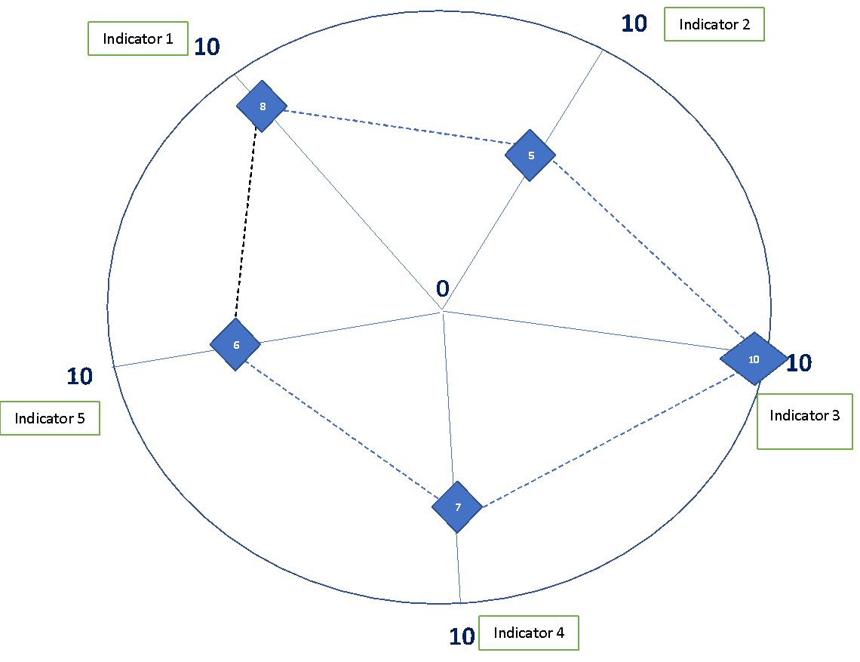
Step 3: Now ask them to rank the case study they just reviewed on each of the indicators based on the target achieved. Tell them that they can also modify the indicators if required. Tell them to map the progress on each indicator at the level of the goal achieved as in handout 6. Tell them that they can rank 10 for a goal achieved and keep reducing the scores accordingly.
Step 4: Once the task has been completed, ask them to present their wheels in a plenary. The discussion should focus on the logic of providing a particular score on any indicator.
Learning Output: Conclude by mentioning that undertaking this exercise at the beginning of the project and then in review meetings can be a good tool for internal monitoring of LNOB progress in projects.

