EVAW and COVID-19
Social Media Package

- Hashtags: #COVID19, #ShadowPandemic
- Please tag: @unwomenasia on Facebook, Twitter and Instagram.

Sometimes home is where the harm is. Women stuck in their homes may be experiencing violence now. Don’t forget to check in with women you know. | 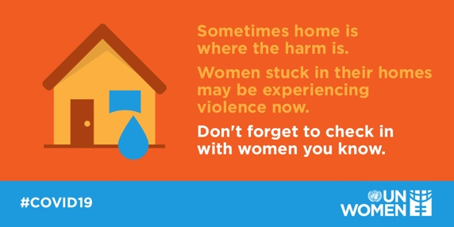
When in lockdown, women may face physical, sexual, psychological and economic violence. If you are experiencing violence at home, reach out for help. Hotlines are working: t.ly/bNF0 | 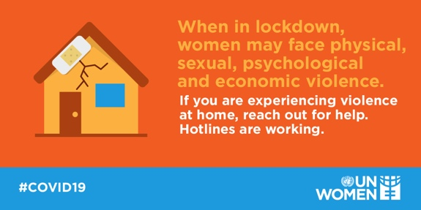
For some women staying home means being locked up with an abusive partner. Check out a hotline number in your country: t.ly/bNF0 | 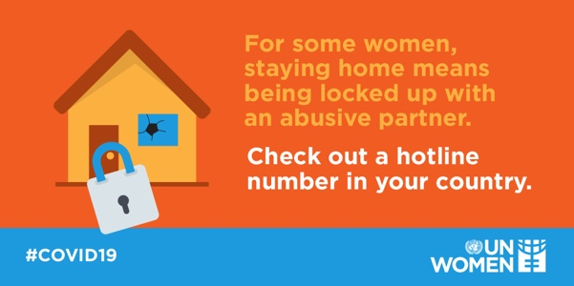
Emergencies such as the #COVID19 pandemic puts women and girls at increased risk of violence. If you hear your neighbor is experiencing violence, don't stay aside. Call the police. | 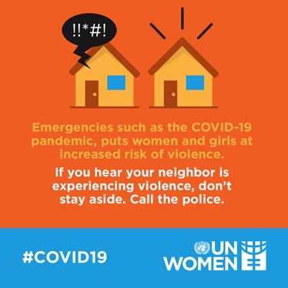
Everyone has a right to be safe at home. Services for survivors of violence/shelters/hotlines are active and are working online. It is not your fault. Seek help t.ly/bNF0 | 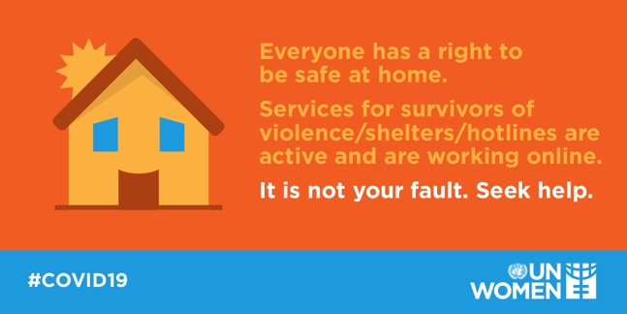
Isolation from family and friends can make domestic violence worse. Check in with women you know. Support services are working and providing support.  t.ly/bNF0 | 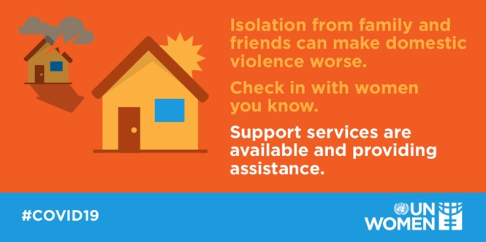
Women abused by partners are at risk during #COVID19. UN Women is working with governments to keep the services for survivors of violence open. Check out services in your countries: t.ly/bNF0 | 